Chapter Three
SECURITIES Markets

cHAPTER OUTLINE

1. How Firms Issue Securities
PPT 3-2 through PPT 3-8
The term primary market refers to the market where new securities are issued and sold. The key characteristic of this market is that the issuer receives the proceeds from the sale. In the secondary market, existing securities are traded among investors. The issuing firm doesn’t receive any proceeds and is not directly involved.

If a primary market offering is made to the general public (a public offering) it must be registered with the Securities Exchange Commission (SEC). SEC approval indicates the issuer has divulged sufficient information for the public to evaluate the offering. Private offerings are not registered, and may be sold to only a limited number of investors, with restrictions on resale.

Investment bankers are typically hired to assist in the issuance process. In a fully underwritten general cash offer (the most common) the banker buys the issue from the issuing firm and pays the bid price. The banker then resells the issue to the public at the ask or offer price. The term “underwriting” is an insurance term that means to take on the risk. The bid-ask spread is the difference between the bid and ask price as a percent of the ask price and represents an issuance cost.

A General Cash Offer (GCO) can be used for an IPO or a seasoned offering. An IPO is the initial public offering versus a seasoned offering which is issuing additional equity after the firm’s IPO. The typical spread for an equity IPO is 7%. IPOs are very expensive. In addition to out-of-pocket costs which may range from $300,000 to $500,000 depending on issue size, most IPOs are underpriced. The investment banker has an incentive to underprice an issue to limit the risk in reselling the issue to the public. Underpricing is a global phenomenon and can be greater than the total out-of-pocket expenses to market an issue. Underpricing averages about 10%.

Investment bankers conduct a nationwide “road show” using a shortened version of the registration statement called a prospectus to solicit interest in a security offering. In the road show, a team of bankers and issuing firm executives will visit brokerage clients and put on a 20-to 40-minute presentation explaining what the issuing firm does and why the security is a good buy. The road show allows the investment banker to build “the book” which contains an indication of interest to buy at a given price. This allows the banker to estimate the demand and to set a price. Many issues are oversubscribed, meaning that customers want to buy more shares than are being offered. This allows the banker to allocate the shares to their better customers and creates a ‘winner’s curse’ problem for a smaller investor. The IPO smaller investors can actually get is not going to be a good IPO, otherwise it would be oversubscribed and no shares would be available. Oversubscription has led to many abuses by Wall Street bankers, who have allocated shares to firms in exchange for subsequent underwriting business and other perquisites. These activities are illegal and have led to large fines for many investment bankers.

GCOs may be competitive or negotiated. In a competitive GCO the issuing firm solicits sealed bids from competing investment banks. In a negotiated deal (by far the most common), the issuing firm works with a lead underwriter to negotiate the terms of the deal. Municipalities may be required to use a competitive- bid process when issuing municipal bonds. Seasoned equity offerings may employ an issue method termed “best efforts,” whereby the investment banker does not buy the issue from the issuing firm, but rather uses brokers’ “best efforts” to sell the security to the public. This is rather infrequently used.

Some firms issue rights offerings in which the new issue is first offered to the existing owners. Some corporate charters require this method. The right to purchase a given amount of new shares,(per owned share) is offered to existing stockholders who then have a time period to exercise their right. In a standby-and-takeup version of the rights offer, the investment banker is hired to ”standby” and ”takeup” or buy new shares that the existing shareholders do not want.

SEC Rule 415 allows shelf registrations which permit a firm to pre-register securities it wishes to sell to the public. Once the shelf registration is approved, the firm may issue the securities at any time within two years by providing the SEC with 24-hour notice of issuance. This provides the issuer with greater flexibility in timing when to market the issue. There are certain minimum-firm-size restrictions to qualify and firms cannot have recently violated certain securities laws and disclosure requirements.
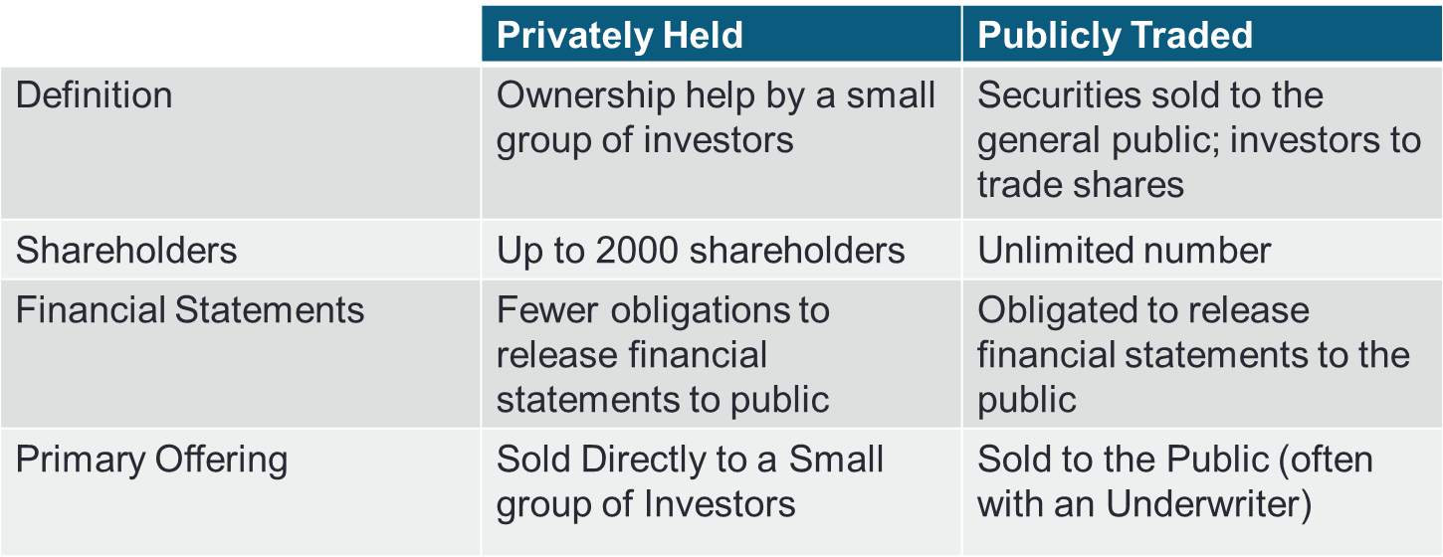

There are differences in the markets for equity and bonds. Bond markets are dominated by financial institutions. Many bond issues lend themselves to private placements. In some years the volume of private placements exceeds public offerings of corporate bond issues.

2. How Securities Are Traded
PPT 3-9 through PPT 3-15
The overarching purpose of financial markets is to facilitate low cost investment.

Markets bring together buyers and sellers at low cost and there are different types of markets:
- Direct search market:
  - Buyers and sellers locate one another on their own

- Brokered market:
  - 3rd party assistance is used in locating a buyer or seller

- Dealer market:
  - 3rd party acts as intermediate buyer/seller

- Auction market:
  - Brokers & dealers trade in one location, trading is more or less continuous

Well-functioning markets provide adequate liquidity by minimizing time and cost to trade and promoting price continuity. Markets should set & update prices of financial assets in such a way as to facilitate the best allocation of scarce resources to investments that will generate the greatest growth in wealth while considering the riskiness of the investment. This function reduces the information costs associated with investing and encourages more people to invest which also allows firms to raise money more cheaply which in turn encourages faster economic growth.

Types of Orders
- Order type
Market orders execute immediately at the best price. Limit orders are orders to buy or sell at a specified price or better. The limit order is placed in a limit-order book kept by an exchange official or computer. For example, if a stock is trading at $50 an investor might place a buy limit at $49.50 or a sell limit order at $50.25. The limit order may or may not execute depending on which way the market price moves. The range around the current price that the limit should be set depends on the price the investor is willing to pay. Setting the price further from the current market reduces the probability of execution.

Stop loss and stop buy orders are also available. A stop-loss order becomes a market-sell order when the trigger price is encountered. For example, you own stock trading at $40. You could place a stop loss at $38. The stop loss would become a market order to sell if the price of the stock hits $38. Similarly a stop-buy order becomes a market-buy order when the trigger price is encountered. For example, suppose you shorted a stock trading at $40. You could place a stop buy at $42. The stop buy would become a market order to buy if the price of the stock hits $42. In both cases, the investor is NOT guaranteed to transact at the trigger price. Rather the stop order will transact at the next transaction, which may or not occur at exactly the trigger price, although it should be close. An investor can also give the broker a discretionary order, to buy or sell at the broker’s discretion, but the investor should really trust the broker. Brokers typically profit when the customer trades. Therefore churning (excessive trading recommendations to generate commissions) is a possibility.

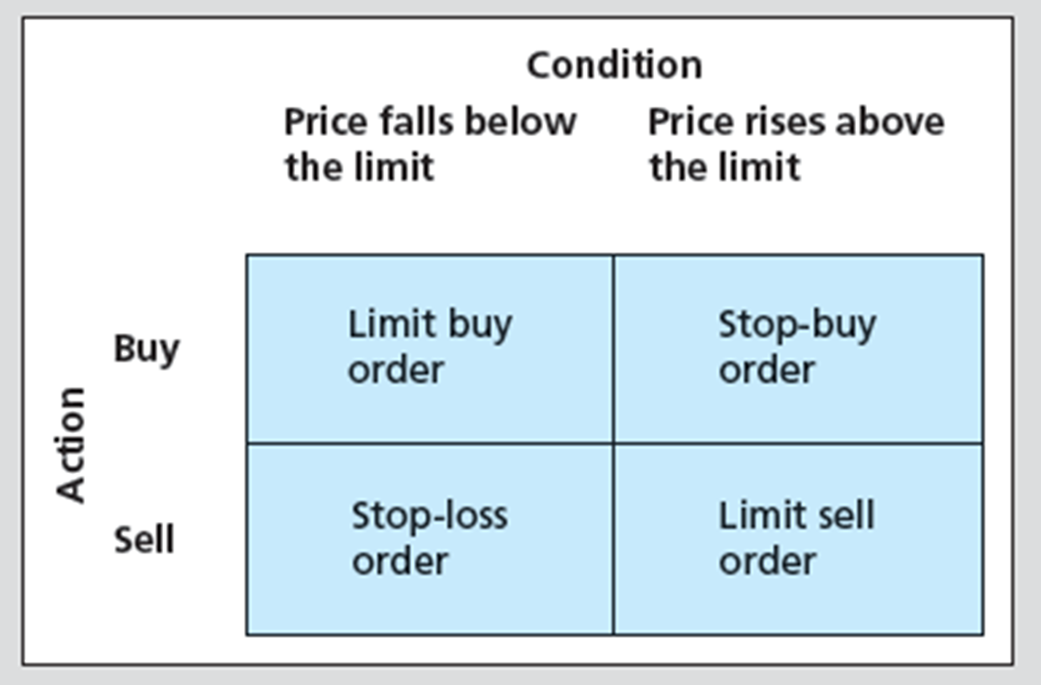

- Time dimensions on orders: Limits and stop orders also have a time dimension. These orders may be immediate or cancel (IOC); good for the day only (Day) (typically the default); or good till cancelled (GTC).

3. The Rise of Electronic Trading
PPT 3-16 through PPT 3-18
New technologies and regulations have driven markets towards electronic trading. The first ECN, Instinet, was established in 1969. In 1975, fixed commissions on the NYSE were eliminated, which freed brokers to compete for business by lowering their fees. In that year also, Congress amended the Securities Exchange Act to create a National Market System to at least partially centralize trading across exchanges and enhance competition among different market makers. In 1994, a scandal involving the NASDAQ drove the SEC to institute new order-handling rules and adopt Regulation Alternative Trading Systems. In 1997, the SEC allowed the minimum tick size to fall from one-eighth of a dollar to one-sixteenth, and in 2001, “decimalization” allowed the tick size to fall to one cent. Slide 18 shows estimates of the “effective spread” during three distinct time periods defined by the minimum tick size. The National Association of Securities Dealers, NASD, spun off the NASDAQ Stock Market as a separate entity in 2000, and the NYSE acquired the electronic Archipelago Exchange in 2006, and renamed it NYSE Arca. In 2005, the SEC adopted Regulation NMS (National Market System), which was implemented in 2007.

4. U.S. Markets
PPT 3-19 through PPT 3-20

A dealer market is a market without centralized order flow. The NASDAQ is a dealer market.
NASDAQ is the largest organized stock market for over-the-counter or OTC trading. NASDAQ is a computer information system for individuals, brokers and dealers. It connects more than 350,000 terminals and processes more than 5,000 transactions per second (Source: NASDAQ). Securities traded include stocks, most bonds and some derivatives.

The country’s largest firms typically trade on the New York Stock Exchange (NYSE). NASDAQ securities tend to be securities of midmarket and smaller firms. NASDAQ has several divisions that correspond to the different size firms. The NASDAQ website has details about the different divisions. Text Table 3.1 contains partial listing requirements for NASDAQ. Stocks that have insufficient trading interest to meet NASDAQ inclusion requirements may trade on the OTC Bulletin Board. The Bulletin Board has no listing requirements. Truly illiquid stocks are referred to as “Pink Sheet” stocks. See www.pinksheets.com for details.

Auction markets are markets with centralized order flow. In these markets the dealership function can be competitive or assigned by the exchange as in the case of NYSE Specialists. Examples include the NYSE, the American Stock Exchange (ASE), the Chicago Board Options Exchange (CBOE), the Chicago Mercantile Exchange (CME) and others.
The unique role of the specialist deserves some attention. The specialist is an exchange-appointed firm in charge of the market for a given stock. A specialist acts as both a broker and a dealer in the market. The specialist is charged with maintaining a continuous, orderly market. At times the specialist will have to trade against a market trend, buying when everyone else is selling and vice versa. Specialists will lose money under these conditions and may petition the exchange to halt trading if their losses mount.

Specialists also act as brokers and receive a commission on trades they facilitate. Commission income has been reduced in recent years as competition from other trading platforms, particularly Electronic Communication Networks (ECNs) has reduced the volume of trading involving the specialists. Several firms have exited the business. The cut in specialist profit margins has also led to ethical breaches with some specialists engaging in front running customers. (In front running the specialist trades for their own account ahead of the customer’s orders, anticipating which way the orders will move the share price.)

5. New Trading Strategies
PPT 3-21 though PPT 3-22
Electronic trading has spawned a number of new trading strategies. Algorithmic trading delegates trading decisions to computer programs. High frequency trading is a special class of algorithmic trading in which computer programs initial orders in tiny fractions of a second, far faster than any human could process the information driving the trade. High-frequency traders compete for trades that offer very small profits. But if those opportunities are numerous enough, they can accumulate to big money. Dark pools are trading venues that preserve anonymity but also affect market liquidity.

6. Globalization of Stock Markets
PPT 3-23 though PPT 3-24
Markets in other countries have roughly similar characteristics to the U.S. markets. The trend is to move toward electronic trading and the specialist system largely unique to the U.S.

7. Trading Costs
PPT 3-25
The costs that may be present in trading are covered in this section. On some trades only a commission is paid. On some trades only a spread may be paid. On many trades both a commission and at least a portion of the spread are paid.

8. Buying on Margin
PPT 3-26 through PPT 3-32
Buying stock on margin is not the same as a margin arrangement in futures. While both futures and stock trading have similar maintenance margins and margin calls, the costs of borrowed funds must be factored into analysis of the returns of stock margin trading. The degree of leverage available in equities is set by the Federal Reserve Board under Regulation T and is less than is typically available in futures.

The IMR or initial margin requirement is the minimum amount of equity an investor must put up to purchase equities. It is currently set at 50%. Thus 1- IMR = maximum percentage of the purchase that the investor can borrow. An investor borrows from the broker. The loan agreement is technically termed a “hypothecation agreement.” Brokers also typically require a minimum dollar amount in a margin account such as $2,500 or $5,000 or higher. This minimum may result in a requirement for the investor to put up equity greater than is needed under the 50% requirement.

The amount of equity in the position will vary as the market value of the underlying stock varies. Equity in the position is calculated as the Position Value – Amount Borrowed. The maintenance margin requirement (MMR) is the minimum amount of equity that the account may have. This is typically 25% for equities. A margin call occurs if the position’s equity is reduced to below the MMR. A declining stock price will reduce the investor’s equity. Equity/Market Value = MMR at the minimum equity necessary to avoid a margin call. We can find the market value at which this will occur by solving the following for market value:
(Market Value – Borrowed) / Market Value ≤ MMR;

A margin call will occur when:

An example is provided in PPT slides 29-31. The example also includes rate-of-return calculations, including loan costs. Students are typically troubled by the return calculations so the instructor should take their time explaining this material.

9. Short Sales
PPT 3-33 through PPT 3-40
With the background developed in margin trading, the concept of short selling is covered next. A brief description of the mechanics of a short sale is first introduced. The instructor may wish to use slide 35 or skip it. Slide 35 compares long positions with short positions.
A short seller has a liability as opposed to an asset. The liability is that the short seller must buy the stock back. Short sales involve margin requirements. The typical margin requirement is 50% but in this case margin is not an outright loan. Rather the margin is used to ensure the investor will be able to buy the stock back if its value increases. Short-sale proceeds must be pledged to the broker (kept in the margin account). The investor must also post 50% of the short sale proceeds in the margin account. The equity of the short position = Total amount in the margin account – Market Value of the security shorted. Short positions also have maintenance margins. A typical maintenance margin may be 30%. As in buying on margin, a margin call may occur if the stock price rises sufficiently. The market value, at which a margin call on a short sale will occur, is when the Market Value = Total Margin Account / (1+MMR).

Typically, the short seller sells stock by borrowing stock from the broker. Most stocks are held in “street name.” This means that the security title remains with the broker. The broker uses internal records to track clients’ positions. A broker can sell stock held in street name for the investor who wishes to engage in a short sale. The short seller is thus liable for any cash flows, such as a dividend that may occur, while the short sale is outstanding.

A naked short sale occurs when the short seller does not have the stock. Naked short selling can lead to excessive speculation not limited by existing supply of shares. Traditionally, exchange-traded stocks could only be sold short if the last price change that occurred was positive. This is the so called zero tick, uptick rule. A short sale could be utilized if the last trade or tick was zero as long as the last price change was to the upside. The zero tick, uptick rule was eliminated by the SEC in July 2007 but there has been discussion about reinstating the rule. During the financial crisis, all short selling was banned for certain financial firms, due to regulator concerns that excessive short selling exacerbated market declines. The rule change had unintended negative consequences for hedge funds which were using short strategies to limit risk of other positions.

10. Regulation of Securities Markets
PPT 3-40
A brief history of securities regulation is provided and the new Financial Industry Regulatory Authority (FINRA) created in 2007 is mentioned. The instructor may wish to cover the Excerpts from the CFA Institute Standards of Professional Conduct.

Recent scandals have rocked the securities markets and a great deal of press coverage has been focused on this area. Regulators are challenged by the changing landscape in trading arrangements and creation of new types of securities. The financial crisis will lead to major, yet-to-be-determined changes in regulation for both banking and securities markets.

The instructor should discuss some of the implications of the Sarbanes-Oxley and how it attempts to align the interest of management and owners of a firm.

As a result, financial innovation will likely suffer. However, historically the financial industry has found methods to work around regulations. It is safe to say that government involvement in the markets is likely to increase and remain at a much higher level than in the recent past.
Reform of ratings agencies is also likely. The top three ratings agencies (Moody’s, S&P and Fitch) were granted a government oligopoly and arguably failed in their duty to accurately rate mortgage-backed-securities risks, CDOs, etc. A conflict of interest exists due to the fact that agencies are paid by the firms they rate. There is also a lack of competition in this industry. The titles of several Wall Street Journal articles follow. These may be assigned to generate discussion in the classroom about the crisis and government’s role in the markets:
- ‘A Crisis of Ethic Proportions: We must Establish a ‘Fiduciary Society,’ by John Bogle, Wall Street Journal Online, April 20, 2009.
- ‘Good Government and Animal Spirits: Every Talented Player Understands the Importance of a Strong Referee,’ by George Akerlof and Robert Shiller, Wall Street Journal Online, April 23, 2009.
- ‘How Business Schools Have Failed Business: Why Not More Education on the Responsibility of Boards?’ by Michael Jacobs, Wall Street Journal Online, April 24, 2009.
- ‘In Defense of Derivatives and How to Regulate Them,’ by Rene Stulz, Wall Street Journal Online, April 6, 2009.
- ‘Can Ethical Restraint Be Part of the Solution to the Financial Crisis?’ by Stephen Jordan, Fellow, Caux Round Table

These articles are largely non-technical and should be easily understandable to an undergraduate finance student.

Excel Applications
Two Excel models are available for margin trading and short sales. These models allow students to examine the impact of margining combined with stock price volatility.

