Chapter Five
Risk and Return: Past and Prologue

Chapter Outline

1. Rates of Return
PPT 5-2 through PPT 5-7
The PPT begins by calculating holding period returns or HPRs and discusses why we calculate returns and sometimes annualize them. Annualizing with and without compounding is illustrated. This should be a review of the students’ basic finance course.

There are several methods for averaging returns over multiple periods. The first choice with respect to averaging is the choice of using the arithmetic or geometric average. The arithmetic average, by the nature of its calculation, assumes that at the start of each period any earnings are withdrawn and the original principal is maintained. Geometric mean calculations assume reinvestment of all gains and losses. The geometric mean will normally be lower because it is a compound return and a smaller growth rate is required for a given set of values if there is compounding. This is a common student question. The geometric mean is lower if the returns vary and the differences between the two will grow with a greater standard deviation of returns, particularly if negative returns are included in the series.

Time-series returns may be averaged through calculating time-weighted returns or via dollar-weighted returns. In time-weighted returns the investor is assumed to hold only one share of the security in each time period. The calculated returns are solely a function of the security performance over the time under evaluation. Once the return series is calculated, either a geometric or an arithmetic average may be calculated. Dollar-weighted returns include the effects of the investor’s choices of when they bought and sold securities. Thus dollar-weighted returns give the investor a truer estimate of the rate of return they earned based on security return performance and their own choices of when they bought and sold the security.

2. Inflation and Real Rates of Return
PPT 5-8 through PPT 5-11
The concept of real versus nominal rates and the Fisher Effect are presented. The reason for needing the exact version of the Fisher Effect is given in a hidden slide with a hyperlink so that the instructor may use it or not. Note that the approximation version and the exact version of the Fisher Effect will diverge at higher rates of inflation. The effects of inflation and taxes on an investor’s return are illustrated. Note that since taxes are paid out of nominal earnings you must take taxes out of the nominal return before finding the real return.

Historical Real Returns & Sharpe Ratios 1926-2008
Series | Real Returns% | Sharpe Ratio
World Stk | 6.00 | 0.37
US Lg. Stk | 6.13 | 0.37
Sm. Stk | 8.17 | 0.36
World Bnd | 2.46 | 0.24
LT Bond | 2.22 | 0.24

Stocks have much higher real returns over long time periods. To illustrate what this implies we can calculate the following future values:
LT Bond portfolio: $1 x 1.022⁸² = $5.96; if you had invested $1 in the LT Bond portfolio for 82 years your $1 would have grown to the equivalent purchasing power of just under $6.
US Large Stock portfolio: $1 x 1.06⁸² = $118.87; if you invested $1 in the US Large Stock portfolio for 82 years your $1 would have grown to the equivalent purchasing power of just under $119.

Interest rates and inflation rates have become more correlated since the 1960s. See Figure 5.1

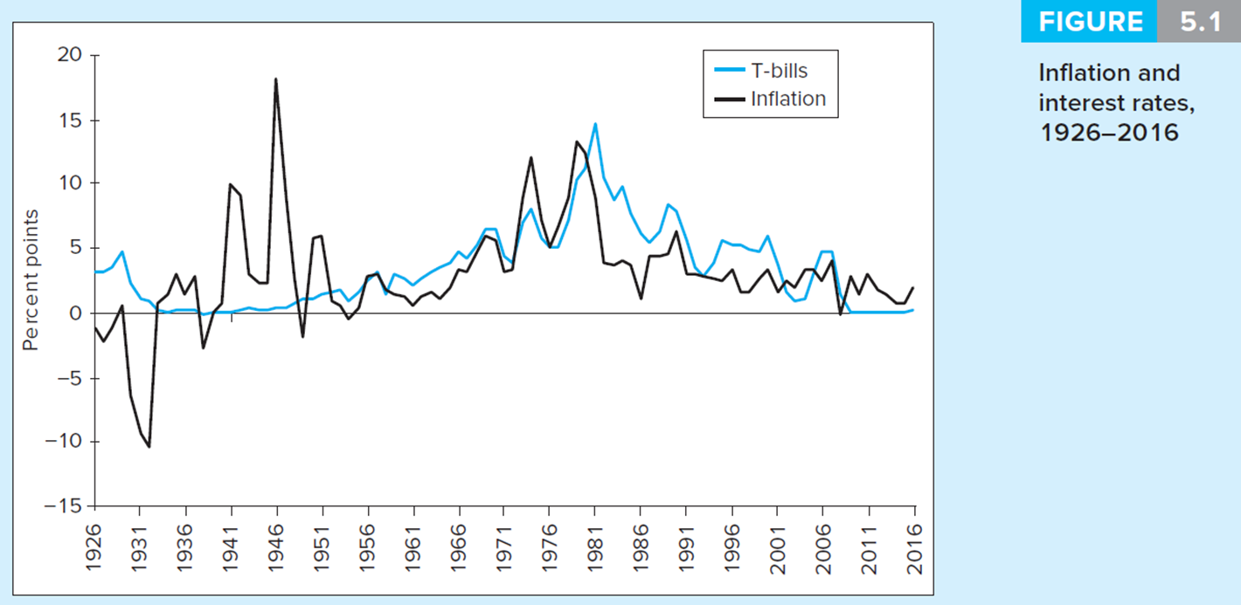

The Sharpe ratio is a measure of the excess return per unit of standard deviation risk. It literally measures the return per unit of risk taken. Higher Sharpe ratios indicate better the performance for that asset class. Notice that the Sharpe ratios are higher for the three-stock portfolios than the bonds. Thus the stocks offered a higher rate of return per unit of risk. Does that mean investors should not hold bonds? No, adding bonds to a stock portfolio will eliminate proportionally more risk than the return sacrificed and can lead to higher Sharpe ratios.

3. Risk and Risk Premiums
PPT 5-12 through PPT 5-21
This section begins by illustrating calculations of expected returns and standard deviation ex-ante for individual securities via scenario analysis. Ex-post average return and standard-deviation calculations are also provided. Basic characteristics of probability distributions are then covered including definitions of mean, variance, skew and kurtosis. For distributions that are skewed, the median and mean returns are different. For normal distributions the mean and variance or standard deviation are sufficient statistics to characterize the distribution.

Value at Risk
Value at Risk attempts to answer the following question:
How many dollars can I expect to lose on my portfolio in a given time period at a given level of probability?
The typical probability used is 5%.
In a given probability distribution we need to know what HPR corresponds to a 5% probability.
If returns are normally distributed then we can use a standard normal table or Excel to determine how many standard deviations below the mean represents a 5% probability:
From Excel: = Norminv (0.05,0,1) = -1.64485 standard deviations. In the Norminv function in Excel the 0.05 is the 5% probability, 0 is the mean and 1 is the standard deviation of a standard normal variate.

From the standard deviation we can find the corresponding level of the portfolio return:
VaR = E[r] + -1.64485σ
For Example:
A $500,000 stock portfolio has an annual expected return of 12% and a standard deviation of 35%. What is the portfolio VaR at a 5% probability level?
VaR = 0.12 + (-1.64485 * 0.35)
VaR = -45.57% (rounded slightly)
VaR$ = $500,000 x -.4557 = -$227,850
What does this number mean? The greatest annual expected loss 95% of the time is $227,85.

VaR is an easily understood quality-control measure. Investment oversight boards can determine whether this loss is acceptable given the portfolio’s goals. The VaR calculation does not require normal distributions. The text illustrates calculating VaR if you have a normal distribution. If options or other complex instruments are included in the portfolio you will not have a normal distribution. You then have to approximate the distribution or perhaps use a Monte Carlo simulation to build a distribution of future returns.

VaR versus Standard Deviation:
For normally distributed returns VaR is equivalent to standard deviation (although VaR is typically reported in dollars rather than in % returns). VaR adds value as a risk measure when return distributions are not normally distributed. Note the actual 5% probability level will differ from 1.68445 standard deviations from the mean due to kurtosis and skewness if these are present. In these cases the standard deviation is a not a sufficient statistic to measure risk.

Risk Premium and Risk Aversion
The risk-free rate is the rate of return that can be earned with certainty. The risk premium is the difference between the expected return of a risky asset and the risk-free rate. The risk premium may be called an ‘excess return.’ The excess return can be depicted as:
Excess Return or Risk Premium_{asset} = E[r_{asset}] – rf

Risk aversion is an investor’s reluctance to accept risk. An investor’s aversion to risk is overcome by offering investors a higher risk premium.

4. The Historical Record
PPT 5-22 through PPT 5-26

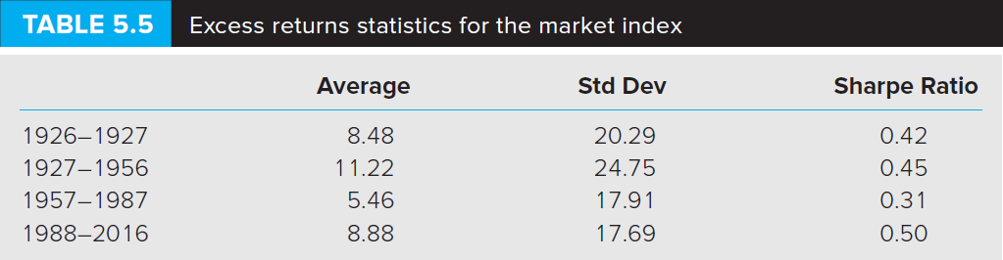
The geometric mean is the best measure of the compound historical rate of return. Nevertheless the arithmetic average is the best measure of the expected return. Sharpe Ratio is the ratio of average excess return over standard deviation. Notice the changing Sharpe Ratios over time in the U.S. market. Table 5.3 shows the different risk and return of the major asset classes. Notice the difference in max and min for the various asset classes.
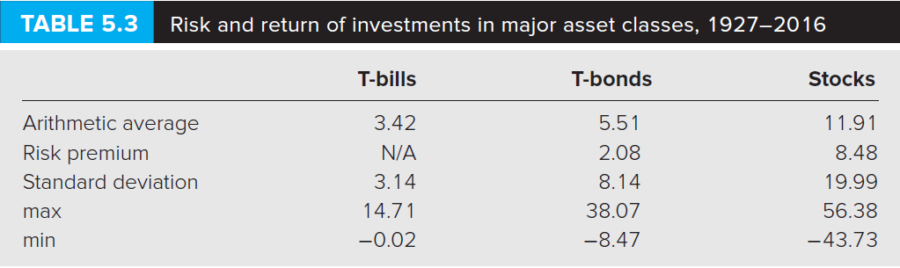

5. Asset Allocation across Risky and Risk-Free Portfolios
PPT 5-27 through PPT 5-31
Investors can choose to hold risky and riskless assets. We may consider investments in a money market mutual fund as a proxy for the riskless investments that an investor might actually engage in. These combinations fall on a straight line (see below) because the standard deviation of the riskless asset is zero and because the correlation between the risky and the riskless asset is zero. Hence all combinations of the risky and the riskless portfolio are linear. The line that depicts the possible allocations between the risky and the riskless portfolio is termed the Capital Allocation Line or CAL.

The CAL is useful to describe risk/return trade-offs and to illustrate how different degrees of risk aversion will affect asset allocation. Risk aversion will impact the combinations chosen by an investor. An investor with a low tolerance for risk will likely prefer to invest some funds in the risk-less asset. An investor with a high tolerance for risk may choose to use leverage. Understanding the CAL now will help students understand the modeling in the next chapter when we consider multiple risky asset combinations.
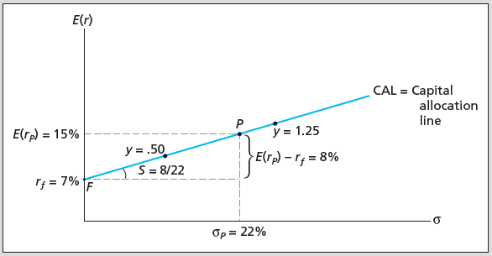
CAL

The expected return is on the vertical axis and the standard deviation of the total portfolio is on the horizontal axis. With all of your money in the risk free asset (F) you will have a 7% return and a zero standard deviation. With 100% of your money in the risky asset you will have a 15% expected return and a 22% standard deviation. Combinations (y) less than one represent varying percentages invested in the risky asset P and (1-y) the percentage invested in the risk free F. Combinations above P are possible by borrowing money at F. This is conceptually equivalent to buying stock on margin. More risk-averse investors would choose a lower y and less risk-averse investors would choose a larger y.

Quantifying Risk Aversion
Some efforts have been made to quantify risk aversion (A). The text assumes that the risk premium or excess return is proportional to the product of the risk aversion level A and the variance of the portfolio.
$$E\left(rp\right)−rf=0\text{.}5×A×σ_{p^{2}}$$
E(r_{p}) = Expected return on portfolio p
r_{f} = the risk free rate
0.5 = Scale factor
A x σ_{p}² = Proportional risk premium
A larger A indicates that the investor requires more return to bear risk. In the asset allocation decision the optimal weight in the risky portfolio P (W_{P}) is: $w_{p}=\frac{E(r_{P})−r_{f}}{{Aσ}_{P}^{2}}$
The coefficient of risk aversion A is generally thought to be between 2 and 4.
With an assumed utility function of the form: U = E[r] - 1/2Aσ_{p}²

The A term can used to create indifference curves. Indifference curves describe different combinations of return and risk that provide equal utility (U) or satisfaction. Indifference curves are curvilinear because they exhibit diminishing marginal utility of wealth. The greater the A the steeper the indifference curve;, such investors will invest less in risky assets. The smaller the A the flatter the indifference curve; such investors will invest more in risky assets.

6. Passive Strategies and the Capital Market Line
PPT 5-32 through PPT 5-33
In a passive strategy the investor makes no attempt to either find undervalued strategies or actively switch their asset allocations. Investing in a broad stock index and a risk-free investment is an example of a passive strategy. The CAL that employs the market (or an index that mimics overall market performance) is called the Capital Market Line or CML. In competitive markets active strategies that entail more information production and trading costs might not consistently perform better than passive strategies after considering those costs. As active investors trade upon information, prices will incorporate that information. This implies that passive investors are able to “free ride” upon the activities of active investors.

Excess Returns and Sharpe Ratios Implied by the CML
The average risk premium implied by the CML for large common stocks over the entire time period is about 8%. But the subperiod variation and the large standard deviation indicate that investors cannot be very confident about using the historical data to estimate what the risk premium is likely to be in any given time period. Sharpe ratios have varied considerably as well. Notice the higher risk premium and Sharpe ratio during the time period including the Great Depression. In periods of economic uncertainty we can expect to see higher risk premiums.

