Chapter six
efficient diversification

Chapter outline

1. Diversification and Portfolio Risk

2. Asset Allocation with Two Risky Assets
PPT 6-2 through PPT 6-17
When we put stocks in a portfolio, σp < Σ(W_{i}σ_{i}). When Stock 1 has a return > E[r1], it is likely that Stock 2 has a return < E[r2] so that return on the portfolio that contains stocks 1 and 2 remains close to its expected return. Covariance and correlation measure the tendency for r1 to be above expected when r2 is below expected.

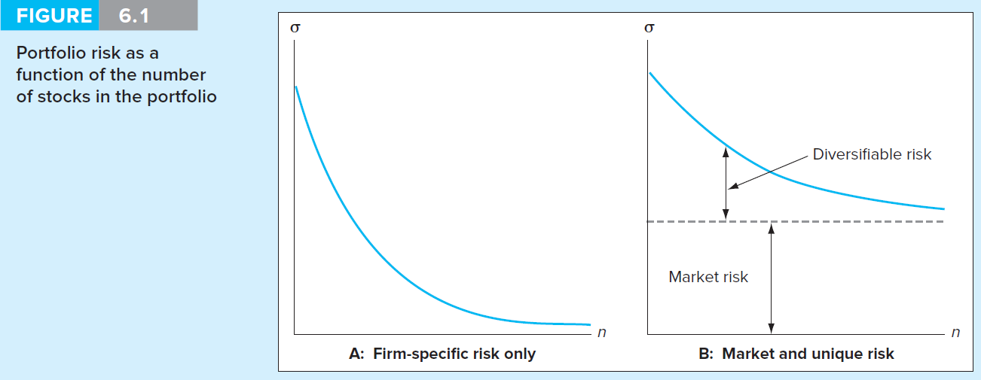

Figure 6.1 illustrates how adding securities to the portfolio reduces the portfolio risk as measured by the standard deviation. Notice size of the standard deviation of a single stock portfolio. With naïve diversification most of the diversification benefits are achieved at about 25 to 30 stocks in the portfolio. Modern portfolio theory, using the asset’s covariances allows us to achieve even better diversification.

Return and Risk of a Two Asset Portfolio
The expected return of a portfolio is simply a weighted average of the returns of the portfolio components. Because of the diversification effects however, the standard deviation of the portfolio is not a simple weighted average of standard deviations of the components. The relevant formulas are as follows:

$σ_{p^{2}}=\sum_{I=1}^{n}{\sum_{J=1}^{n}{[W_{I}{\text{ W}}_{J}\text{ Cov}(r_{I}{\text{,r}}_{J})]}}$

$\begin{aligned}W_{I}{\text{,W}}_{J}=\text{Percentage of the total portfolio invested in stock I and J respectively} \\ \text{n }=\text{ The total number of stocks in the portfolio}\end{aligned}$

$\text{Cov}(r_{I}{\text{,r}}_{J})=\text{Covariance of the returns of Stock I and Stock J}$

$\text{If I }=\text{ J then Cov }(r_{I}{\text{,r}}_{J})={\text{ σ}}_{I^{2}}\text{ \& Cov}(r_{I}{\text{,r}}_{J})=\text{Cov}(r_{J}{\text{,r}}_{I})$

For the two asset portfolio:
$σ_{p^{2}}=W_{1^{2}}σ_{1^{2}}+2W_{1}W_{2}\text{Cov}(r_{1},r_{2})+W_{2^{2}}σ_{2^{2}}$

σ₁² = Variance of Security 1
σ₂² = Variance of Security 2
Cov(r₁r₂) = Covariance of returns for Security 1 and Security 2

The PPT provides ample detail about the correlation coefficient and about why correlations are easier to interpret than covariance. This detail can be skipped if your students are reasonably proficient in statistics. Note that for an n security portfolio the portfolio standard deviation calculation will be comprised of n variances but n(n-1) covariances. As you add more securities to the portfolio, the covariance terms dominate the risk calculation and the individual security standard deviations matter less.

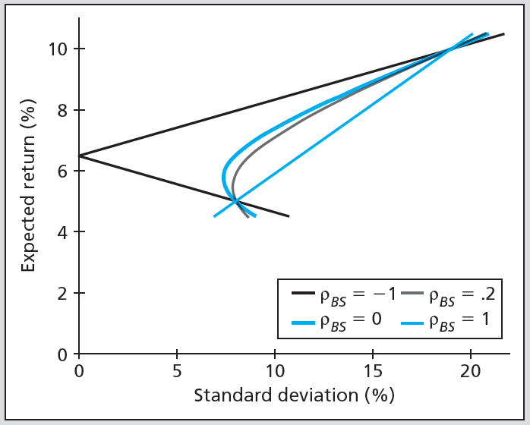

The graph depicts return/risk combinations of two securities, A and B for different hypothetical correlation coefficients. If there is a perfect positive correlation between A and B, combining the two securities yields no diversification benefits and combinations of A and B fall on a straight line because in this case σ_{p} =Σ W_{i}σ_{i}. However if the assets are perfectly negatively correlated, we can combine the two securities to completely eliminate variance in the combined portfolio. Generally asset correlations will be between -1 and +1 and the combinations can eliminate some risk but not completely remove it. It is critical that students understand that diversification will improve the Sharpe ratio, this is why people diversify.

In the two-asset case it is fairly easy to calculate the minimum variance weight with the following equations:
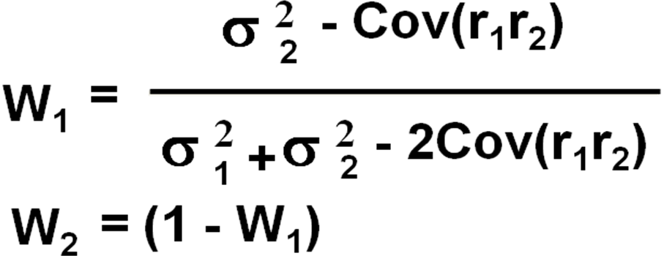

Once the weights are known, the minimum variance portfolio expected return and risk can be calculated.

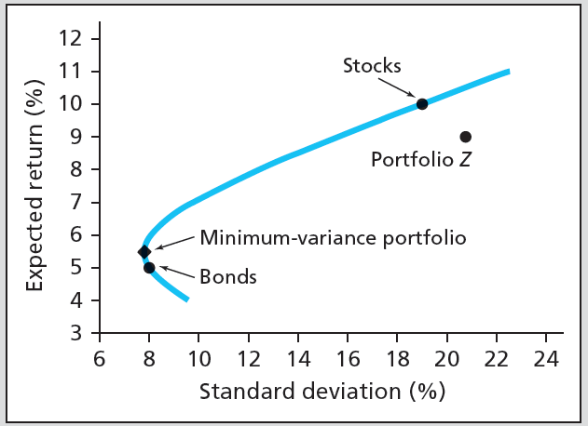
From this point in the development it is an easy step to illustrate the minimum variance set and the efficient frontier for large numbers of securities. Considering many risky asset combinations (and always keeping the combinations that have the least risk for a given return level) one can build a minimum-variance frontier. In actuality however we are only concerned with the upper portion of the curve. Any minimum variance point on the bottom of the curve can be dominated by the similar point on the upper portion of the curve. The curve from the global minimum-variance portfolio, up and to the right, represents the efficient frontier, which are the best diversified combinations or the least risky for each possible expected return level.

The text also illustrates the benefits of diversification, using historical data to examine the effects of including stocks and bonds in a portfolio during some of extreme loss years. The overall standard deviation of the diversified portfolio that includes bonds is smaller than the standard deviation of either stocks or bonds individually. Thus, combinations that include bonds are likely to have higher Sharpe ratios, that is, more return per unit of risk.

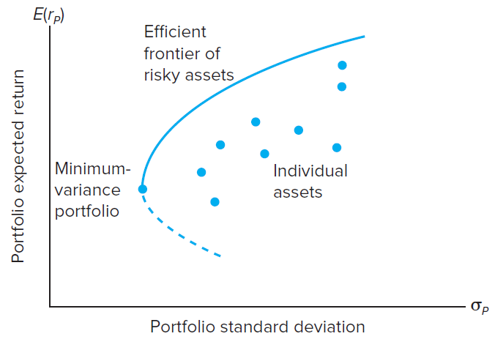

Combinations that provide more return per unit of risk are superior regardless of an individual’s risk tolerance due to the principle of separation which holds that that portfolio choice can be separated into two independent tasks: (1) determination of the optimal risky portfolio and (2) the personal choice of the best mix of the risky portfolio and the risk free asset. This is a crucial point. It means that a widow (with high risk aversion) and a ‘yuppie’ (a young upwardly mobile professional with low risk aversion) should both choose the same risky portfolio. Their asset allocations in their complete portfolios would differ however with the widow choosing to put a higher percentage of her money in the risk-free asset than the yuppie. The PPT illustrates the separation property with indifference curves.

3. The Optimal Risky Portfolio with a Risk-Free Asset

4. Efficient Diversification with Many Risky Assets
PPT 6-18 through PPT 6-29
The inclusion of a risk-free asset in a portfolio results in a single combination of stock and bonds that is optimal when that portfolio is combined with the risk-free asset. As explained in Chapter 5 the resulting capital allocation line is now linear. This is because the covariance between the risk free asset and the risky portfolio is zero.

At this point the Capital Market Line or CML can be developed as the optimal Capital Asset Line (CAL) that results from combining the risk free asset with the efficient frontier as depicted below:

CAL(P) = Capital Market Line or CML dominates other lines because it has the largest slope or equivalently, the largest Sharpe ratio
Slope = (E(r_{p}) - rf) / σ_{p}
That is, the CML maximizes the slope or the return per unit of risk or it equivalently maximizes the Sharpe ratio. Regardless of risk preferences, some combinations of risky portfolio P & and risk-free asset F will dominate all other combinations. All investors’ complete portfolio will fall on the CML.

In this graph we have two investors with different levels of risk aversion. The A coefficient of 2 indicates a high level of risk aversion and a steeper indifference curve. A steep indifference curve indicates a high level of additional return required by the individual investor to bear risk. The slope of the indifference curve is the marginal rate of substitution (MRS). The slope of the CML is the marginal rate of transformation (MRT). The optimal complete portfolio is found on the CML where the MRS = MRT.

Practical Implications
The analyst or planner should identify what they believe will be the best performing well-
diversified portfolio, call it “P”. P may include funds, stocks, and bonds, as well as international and other alternative investments. This portfolio will serve as the starting point for all
their clients. The planner will then change the asset allocation between the risky portfolio and “near cash” investments according to the risk tolerance of the individual client. The risky portfolio P may have to be adjusted for individual clients for tax and liquidity concerns, if relevant, and to adjust for the client’s unique circumstances.

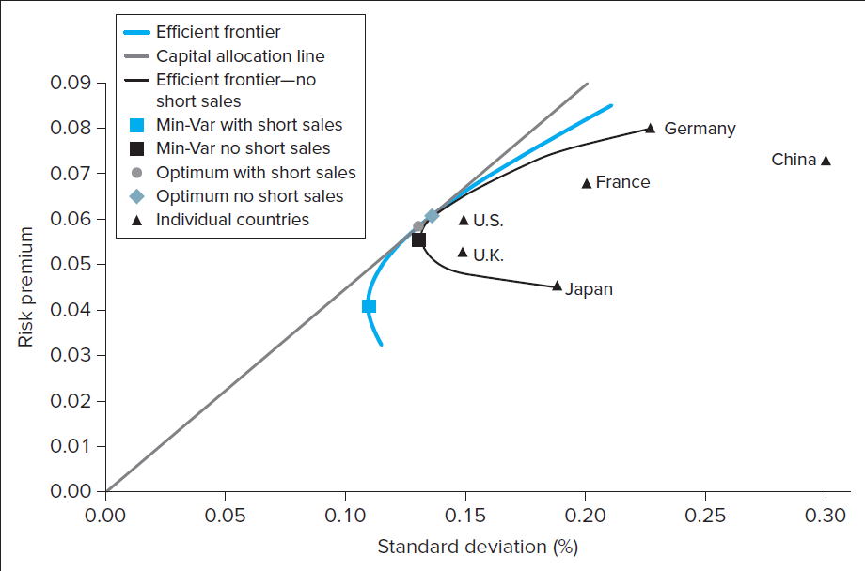

5. A Single Index Asset Market
PPT 6-30 through PPT 6-38
We have learned that investors should diversify, thus individual securities will be held in a portfolio.
The risk that cannot be diversified away, i.e., the risk that remains when the stock is put into a portfolio, is called systematic risk. Systematic risk is also called non-diversifiable risk. Systematic risk arises from events that affect the entire economy. Examples of such events include a change in interest rates or GDP; or a financial crisis such as that which occurred in 2007 and 2008. If a well diversified portfolio has no unsystematic risk then any risk that remains must be systematic; the variation in returns of a well-diversified portfolio must be due to changes in systematic factors. We have already learned that covariance is the predominant statistic in determining the risk of a portfolio. Similarly, the systematic risk of an individual stock is a function of the covariance of the stock and the well-diversified portfolio.

The single-factor model of excess returns can be used to estimate a security’s beta.

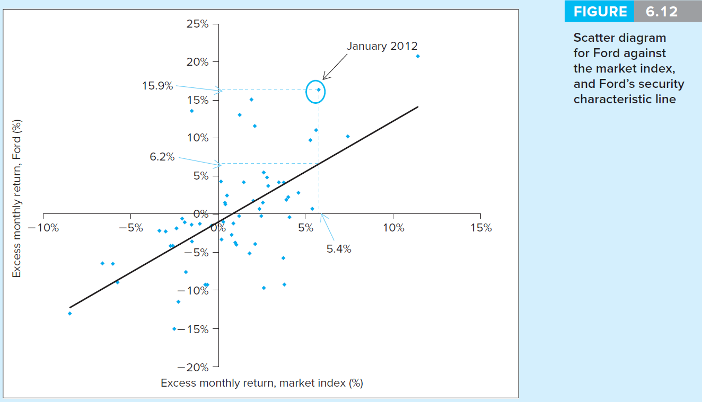

Each point would represent a sample pair of excess returns observed for a particular holding period. A regression analysis will find the “best fit” line for the data. The expected return for the security, when the market has zero excess return, is the point where the line crosses the vertical axis. This is referred to as alpha. Beta is the slope of the regression line. A higher beta means higher systematic risk. Betas above 1 are riskier than the market since a regression of the market excess returns versus market excess returns would, by definition, yield a beta of 1.

The scatter plot can also be used to illustrate systematic and unsystematic risk. The risk is related to the systematic or macroeconomic factor, in this case the market index. A stock’s total risk, as measured by its standard deviation, can be partitioned into systematic and unsystematic risk.
The advantages offered by the single-index model are described in the PPT. Since the relationship of each security is compared or related to the common index, data requirements are much smaller than they would be if each pair-wise correlation was measured. Betas also provide an easy reference point since the market beta is 1.

The Treynor-Black Model (advanced topic)
If a manager has the ability to find undervalued stocks, what strategy should a portfolio manager use in investing in those stocks? The percentage of funds allocated to undervalued stocks depends, in part, on the ability of the manager. If a manager has perfect foresight, theoretically all funds should be placed in the most undervalued stocks. If the manager has substantial funds, buying pressure could make that impossible. The risk of such a strategy would be extreme. Most portfolio managers do not have a perfect ability to identify undervalued securities. For most managers, the process involves some passive investment in stocks in addition to acquiring the undervalued stocks.

The Treynor-Black Model is used to combine an actively-managed portfolio with a passively-managed portfolio. A reward-to-variability measure, similar to the Sharpe measure, is used to determine optimal allocations in the active and passive portfolio. To determine optimal allocations, the portfolio manager must be able to forecast expected returns and risk for both the actively managed and passively managed portfolios. The relevant measure of risk for the actively managed portfolio is its ratio of alpha to nonsystematic risk.

By combining the active and passive portfolios, the manager can achieve a superior reward-to-risk combination. Understanding the results of the Treynor-Black Model is best accomplished through a graphical presentation. A graph is provided in the PPT. The standard Capital Market Line (CML) is shown in the graph. The portfolio of actively managed stocks is shown as point A. Portfolios A and M are combined in the optimal mix that is displayed as point P. The Capital Allocation Line (CAL) shows the combination of the Risk-free rate and portfolio P. The CAL dominates the CML.

The Treynor-Black Model details (advanced topic)
“Well performing” individual stocks held in diversified portfolios can be evaluated by the stock’s alpha in relation to the stock’s unsystematic risk. Suppose an investor holds a passive portfolio M but believes that an individual security has a positive alpha. A positive alpha implies the security is undervalued. Suppose Google has the positive alpha. Adding Google moves the overall portfolio away from the diversified optimum, thus bearing residual risk that could be eliminated; however, it might be worth it to earn the positive alpha. We need to determine the optimal portfolio including Google and the resulting improvement in the Sharpe ratio. These can be found as follows:
- $W_{G}^{}=\frac{W_{G}^{O}}{1+W_{G}^{O}(1−β_{G})}{\text{; W}}_{M}^{}=1−W_{G}^{}\text{ G }=\text{ Google, M}=\text{Passive}$Weight of Google in the optimal portfolio O:

- $S_{O}^{2}−S_{M}^{2}={\left(\frac{α_{G}}{σ(e_{G})}\right)}^{2}$The improvement in the Sharpe ratio (S) over the Sharpe of the passive portfolio M can be found as:

- $\left(\frac{α_{G}}{σ(e_{G})}\right)\text{; }$Notice that the improvement in the Sharpe ratio is a function of:

  - This ratio is called the “information ratio.”

- $\sum_{i}^{n}{\frac{α_{i}}{σ^{2}(e_{i})}=}\frac{α_{1}}{σ^{2}(e_{1})}+\frac{α_{2}}{σ^{2}(e_{2})}+\text{.}\text{.}\text{.}\frac{α_{n}}{σ^{2}(e_{n})}$For multiple stocks in the active portfolio:

- $W_{i}^{}=\frac{α_{i}σ^{2}(e_{i})}{\sum_{i}{α_{i}σ^{2}(e_{i})}}$The optimal weight of each security in the active portfolio is found as:

- A larger alpha increases the weight of stock i and larger residual variance reduces the weight of stock i.
- $α_{A}=\sum_{i}^{n}{W_{\text{iA}}}α_{\text{iA}}\text{ ; }β_{A}=\sum_{i}^{n}{W_{\text{iA}}}β_{\text{iA}}$$σ^{2}(e_{A})=\sum_{i}^{n}{W_{\text{iA}}^{2}}σ_{\text{iA}}^{2}$If A stands for the “active portfolio,” the active portfolio’s alpha, beta and residual risk can be found from:

6. Risk of Long-Term Investments
PPT 6-38 through PPT 6-39
The last section of this chapter provides a comparison of the variance and standard deviation of short-term and long-term investments. PPT 6-41 and PPT 6-42 present a calculation for variance and standard deviation on an investment. The investment’s rate of return in each year has an identical standard deviation and the returns for each year are uncorrelated with each other. An important conclusion is that the correct comparison between securities of different maturities should be based on risk of the total rate of return which accounts for both magnitudes as well as probabilities of possible losses. While average risk per year may be smaller with longer horizons, that risk compounds when applied to a greater number of years, which makes the cumulative investment outcome riskier.

Excel Applications
Several Excel applications are discussed in the text and one Excel model is available on the website that can be used to apply the concepts covered in Chapter 6. The model constructs an efficient portfolio for many securities. The model constructs efficient combinations of the securities using the “solver” function in Excel. The model is built to minimize the standard deviation for a specified target rate of return. The model is built with restrictions to positive investment amounts but it can be modified to allow short selling.

