Chapter Seven
capital asset pricing and arbitrage pricing theory

Chapter Outline

1. The Capital Asset Pricing Model
PPT 7-2 through PPT 7-12
The introduction of the CAPM starts with an overview of the importance of the model and the assumptions that underlie it. The implications or conditions that will result from the CAPM are provided. Once the major implications and conditions have been discussed, the Capital Market Line can be examined. In discussing the CML, it is important to stress that any complete portfolio on the CML will dominate all portfolios on the efficient frontier (other than the tangency portfolio).

The resulting conclusion is that investors, regardless of their risk preferences, will combine the market portfolio with the risk-free investment. Since the equilibrium conditions result in all investors holding the same portfolio of risky investments, pricing of individual securities is related to the risk that individual securities have when they are included in the market portfolio. The relevant measure of risk is the covariance of returns on the individual securities with the market portfolio.

The Security Market Line (SML) graphically depicts the market price of risk. The beta for the individual security is the [Cov (r_{i},r_{m})]/Var r_{m}. The beta is the measure of the amount of systematic risk a stock has, or equivalently the amount of risk a stock will have when it is put into a well diversified portfolio. Thus, the product of the market wide price of risk (r_{m} – rf) / β_{m} times β_{i} is the premium for bearing risk; and the required return for a security that compensates for its systematic risk is risk premium (described above) plus the risk-free rate. The SML can also be used to illustrate a security’s alpha. Portfolio betas are simple weighted averages of the component security betas and are easy to calculate.

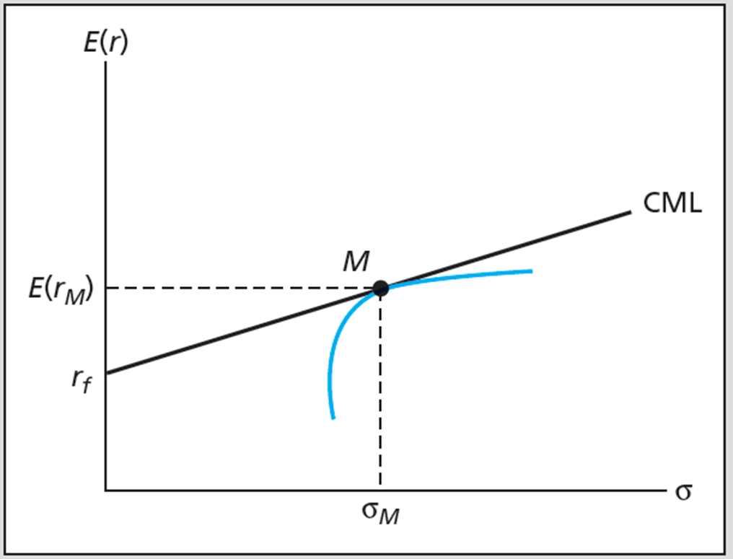

Expected Returns on Individual Securities will be governed by the following relationship:
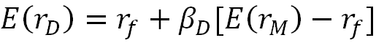

2. The CAPM and Index Models
PPT 7-13 through PPT 7-16
Development of an index model and an example security characteristic line (SCL) are provided. Using regression analysis and the risk premiums for individual stocks, the slope of the relationship is the beta for an individual stock.

In the PPT the concept of adjusted betas is presented. The depth in which you choose to cover this topic should depend on the background of your students. You may wish to spend some time in class developing confidence intervals and discussing the notion of statistical significance. The significance of the alpha and beta measures is an important item to be discussed in class if the student’s preparation in statistics is adequate.

3. CAPM and the Real World
PPT 7-17
This brief section gives some background about some of the main conclusions that can be drawn from studies of the real world applicability of the CAPM. Although the model cannot be directly tested (remember Roll’s critique) the practicality of the CAPM as it applied can and has been extensively tested. The main conclusion of these tests is that there may be better measures of the risk premium than the estimates we use following the CAPM.

This is the motivation for the Fama-French model described in the next section. As an aside, we can conclude that the CAPM is false based on the validity of its assumptions. Nevertheless the concepts from the CAPM remain valid and very important -- in particular, investors should diversify; only systematic risk matters; and a well-diversified portfolio can be suitable to a wide range of investors with different risk tolerances.

A broker or planner will still wish to identify the best-performing set of risky investments, chosen for maximum diversification at a target return level. This portfolio will be optimal for investors with different risk tolerances. Asset allocation adjusts for risk tolerances. Some people tend to equate the idea of efficient markets with the CAPM. We have to be careful with this linkage however. If the CAPM assumptions and results are completely valid then the markets would have to be, de facto, informationally efficient. However if the CAPM is false this only says that our model of expected returns is wrong and it technically says nothing about information efficiency.

4. Multifactor Models and the CAPM
PPT 7-18 through PPT 7-20
The aforementioned limitations of the CAPM theory eventually led to the development of multifactor models and the arbitrage pricing theory. These models either downplay or eliminate the central role of the market portfolio, which is unobservable anyway. The Fama-French (FF) three factor model has become a standard in equity analysis. The FF model was developed because the researchers found that stocks of smaller firms, and of firms with a high book-to-market ratio, had higher stock returns than predicted by single factor models. The FF model is based on empirical regularities that are apparently longstanding in the data. Nevertheless it is a model without a sound theoretical underpinning. This raises questions about whether the priced factors will remain significant in the future.

5. Arbitrage Pricing Theory
PPT 7-21 through PPT 7-26
After laying the conceptual groundwork and defining terms, the concept of arbitrage pricing for well- diversified portfolios is presented in the PPT. Arbitrage opportunities exist if an investor can construct a zero investment portfolio with a sure profit. If such opportunities exist, an investor can take large positions to secure riskless profits. In efficient markets, if profitable arbitrage opportunities exist, traders will take positions to secure the riskless profit and we should expect such opportunities to disappear quite quickly. The PPT also covers some of the most significant difference between the APT and the CAPM and some practical difficulties in using the APT.

