Chapter Eight
The efficient market Hypothesis

Chapter OUTLINE

1. Random Walks and the Efficient Market Hypothesis
PPT 8-2 through PPT 8-6
Definitions of informational and allocational efficiency are provided. Implications of efficiency are then discussed and the idea of random walk is introduced and illustrated. Note that we actually expect there to be a positive trend in stock prices albeit with random movements around those positive trends. The reason that we would expect to see price changes that are random is related to efficiency. If information that has importance for stock values arrives or occurs in a random fashion, price changes will occur randomly. If the market is efficient in its analysis, the change in prices will reflect that information in a timely basis.

The result will be random price changes. The concept of market efficiency is related to the concept of competition. In efficient markets, once information becomes available, participants will trade quickly on that information. Competition assures that prices will reflect that information very quickly. If the information does not become incorporated into price very quickly, market participants would act to eliminate the inefficiency.

Questions arise about efficiency due to possible unequal access to information, structural market problems and the psychology of investors (behavioralism). Structural market problems refer to market imperfections. These include transaction costs limiting arbitrage, constraints on short sales doing the same and recognizing that in volatile markets, most arbitrage strategies are really risky arbitrage, not riskless arbitrage. We will have more to say on this later.
The forms of the efficient market are presented. In a weak-form efficient market, prices will reflect all information that can be derived from trading data such as prices and volumes. In a semi-strong form, market prices will reflect all publicly available information regarding the firm’s prospects. In a strong-form market, prices would reflect all information relevant to the firms' prospects, even inside information. It is important that students understand the following Venn diagram.

Many students struggle with this concept so it is worth taking the time to point out the relationships among the different forms of efficiency.

2. Implications of the EMH (for Security Analysis)
PPT 8-7 through PPT 8-10
Technical and fundamental analyses are defined in this section as well as the implications of the different forms of market efficiency with respect to security analysis. If markets are weak-form efficient, technical analysis, such as charting, should not result in superior profits. If markets are semi-strong form efficient, fundamental analysis should not result in consistent superior profits. Fundamental analysis involves using information on the economy as well as information such as earning trends and profit trends to find undervalued securities. If markets are at least semi-strong efficient, investors would tend to employ passive strategies such as buying indexed funds or employing a diversified buy-and-hold strategy. Active management such as security analysis or attempting to time the market would not result in consistently superior profits if markets are efficient.

Even when markets are efficient, portfolio management is required. For one thing, the appropriate risk level will vary over an investor's life. Tax considerations will call for different types of securities to be included in the portfolio. Other considerations could be related to reinvestment risk associated with cash flow; or considerations related to diversifying employment-related risk.

3. Are Markets Efficient?
PPT 8-11 through PPT 8-22
Over time stock prices tend to follow a submartingale. This has nothing to do with efficiency, per se. It does however have serious implications for tests of efficiency. This implies that a randomly chosen portfolio of stocks can be expected to have a positive return. In practice this means that when trying to figure out if some portfolio manager is earning abnormal returns we must compare their performance to the performance of a randomly chosen portfolio. That is, they must outperform the random portfolio or, in practice, they must beat some benchmark rate of return. The magnitude, selection bias and lucky-event issues are covered, as well as possible model misspecification. Because a model of expected return is needed to assess whether an investor or an investment rule earns excess return, tests of market efficiency are joint tests of the model used to estimate expected returns and market efficiency. Therefore, even when an anomaly is discovered, we have to be careful in interpreting the results. Some apparent anomalies are discussed including the Fama-French results, the Keim and Stambaugh findings and the Campbell and Shiller work. Note that each of these results may also be consistent with changing risk premiums and may have nothing to say about market efficiency. Some anomalies do not have staying power after being reported.

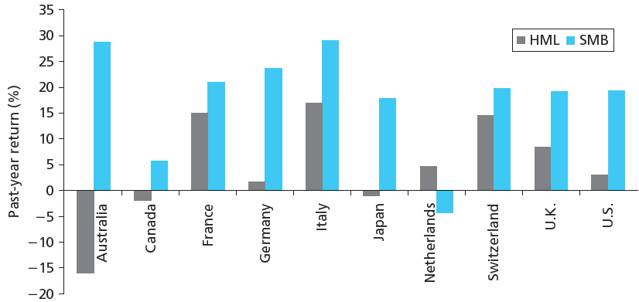

Periodically, stock prices appear to undergo a ‘speculative bubble.’ A speculative bubble is said to occur if prices do not equal the intrinsic value of the security. Does this imply that markets are not efficient? There is no definitive answer to this question. However we can make some observations:
- It is very difficult to predict if you are in a bubble and when the bubble will burst. Stock prices are estimates of future economic performance of the firm and these estimates can change rapidly.
- Risk premiums can change rapidly and dramatically.

Nevertheless, with hindsight there appear to be times when stock prices decouple from intrinsic or fundamental value, sometimes for years. What does this imply?

- Prices eventually conform once more to intrinsic value. Many who don’t believe in efficient markets anyway have jumped on this result to pronounce the death of market efficiency. However, the bubbles bring into question the allocational efficiency of the markets more than the informational efficiency. Very few people will be able to consistently predict the extent and duration of a bubble.
- Some claim the bubbles imply that investors are irrational. Perhaps, but think about what determines the price of gold. Is it irrational to buy an asset for more than its fundamental value if you believe that you can sell it for more than you paid for it? It is indeed risky to engage in this type of transaction, but is it irrational?
- Bubbles seem to occur during two periods: 1) when technology is changing rapidly and 2) during periods of cheap capital when interest rates are low for extended periods. In the first case, values will be more heavily determined by future growth prospects rather than the value of assets in place. During periods of cheap capital, new investments will be undertaken based on future growth prospects as well. In both situations, new investors with less investment knowledge and experience are likely to enter the markets, making a bubble even more likely. When the bubble bursts, there will appear to be a return to hardnosed rationality as investors look carefully to invest according to their beliefs about fundamental values and will employ higher risk premiums. For more on thoughts on this topic (and more history about bubbles) read Burton Malkiel’s book, “A Random Walk Down Wall Street” to learn how ‘Castles in the Air’ sometimes outweigh fundamental values in price setting.

Some of the major types of tests that researchers have done on market efficiency are described. If markets are inefficient, then professionals who spend considerable resources in investment should secure superior performance. The tests are broken down in terms tests of the forms of efficiency. Tests have uncovered some inefficiency in pricing but many possible interpretations of results are possible. Tests of weak-form efficiency show small magnitudes of positive correlation for very short term tests; hence prices do not strictly conform to a random walk. Studies of returns for periods of 3 to 12 months offer evidence of positive momentum. Longer horizon tests have uncovered some pronounced negative correlation. Tests do document tendencies for long term reversals in results. This may be because of information flow in competitive markets. People rush to buy recent winners and in so doing drive up the price enough so that future returns are not abnormal. This does not imply inefficiency unless the same investors can consistently do this. Attempting to interpret the results of efficiency tests has led to various explanations ranging from model misspecification to data mining.

4. Mutual Fund and Analyst Performance
PPT 8-23 through PPT 8-30
Some recent studies on mutual funds have documented some persistence in positive and negative performance. Some researchers question whether the performance is abnormal or whether the studies have measurement errors or model biases. The overall test results are mixed at best but the evidence shows that some superstars exist. Note that Warren Buffet’s portfolio, (Buffet is one of the postulated superstars) took quite a beating in the financial crisis of 2008. Although the evidence is not conclusive, it appears safe to state that the ability to consistently earn abnormal returns, greater than one should for the risk level undertaken, is very rare.

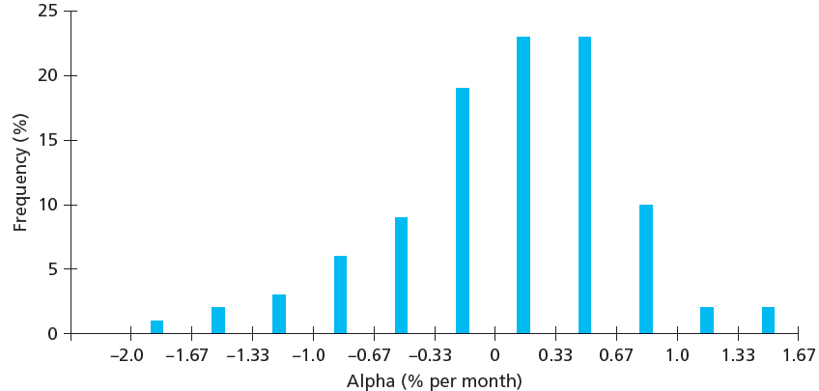

The instructor might want to end with the question “So, are Markets Efficient?” The evidence seems to suggest that they are efficient nough that only differentially superior information will earn money. Professional manger’s margin of superiority are likely too slight for statistical significance and economic gain for the investors.
