Chapter Nine
Behavioral Finance and Technical analysis

Chapter Outline

1. The Behavioral Critique
PPT 9-2 through PPT 9-14
The area of behavioral finance is relatively new but has been growing in popularity. The behavioralists offer explanations of asset pricing that may perhaps explain some of the observed anomalies in efficient markets, although other explanations are possible. The purpose of behavioral finance is to improve decision making under uncertainty by considering information processing errors that can lead investors to misestimate true probabilities of possible events or rates or return. Various commonly posited examples are explained in the PPT. If the instructor has time, it is illustrative to “test” the students with some of the original Kahneman and Riepe experiments (http://jpm.iijournals.com/content/24/4/52)

Psychologists also believe that individuals would tend to make less-than-fully-rational decisions even if they used perfect information processing. The impetus for the growth of behavioral research has been the dot-com and the housing bubbles. Whether behavioralism will remain as popular in today’s environment remains to be seen. Extrapolation bias and overconfidence can occur if an analyst or investor places too much confidence in historical statistical behavior. For instance, believing that earnings will continue to rise simply because they have for the last eight quarters will lead to underestimating volatility and overestimating value. Some of these problems have arisen because of a general overreliance on historical data in making forward estimates and also an overweighting of recent results. Future performance will be strongly affected, if not determined by future economic events not historical results.

Using historical data as the main basis for a forecast is tantamount to using the data as a technical trading rule. Like many technical rules it will work for a time, until it stops working, because the underlying economic fundamentals change. Anchoring bias, or conservatism, is a similar phenomenon. The PPT refers to framing errors. This term refers to a person’s tendency make a different decision with same set of facts if they are framed differently. Regret avoidance and loss aversion are examples of framing decisions. Some individuals tend to increase risk if they believe they are facing a loss anyway in an attempt to avoid the loss. They may choose to do this even if the risk is not a fair gamble. This is not ‘rational’ for a risk-averse investor.

Standard utility (satisfaction) theory versus prospect theory
In standard utility theory of investments, investors desire more wealth and less risk. Wealth provides diminishing marginal utility; thus a gain of $1,000 provides less utility than the utility loss from losing $1,000. This gives rise to risk aversion. Prospect theory is an alternative behavioral-based theory that asserts that investor utility depends on the change in wealth from the start of the investment rather than on the starting level of wealth.

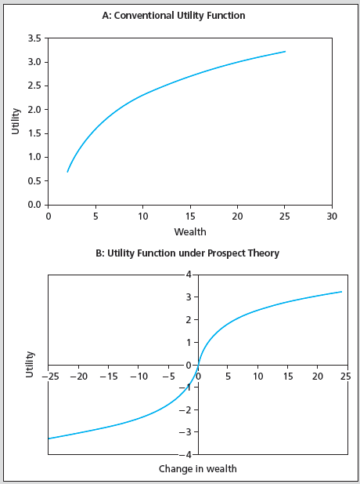

Prospect theory is an example of loss aversion. To the right of zero, the investor acts like a typical risk-averse investor with diminishing marginal utility as the increase in wealth becomes larger. To the left of zero, in Panel B, an investor is “in the domain of losses” and their behavior may change; they may become risk seeking. In other words, if you think you are going to take a loss, you are more likely to take a risk in hopes of avoiding the loss, even if it is not a good gamble. Consider conducting a class exercise to demonstrate that some people do exhibit loss aversion. This may explain why people are reluctant to sell losers in their portfolio, holding on to them during periods of declining performance.
- A typical response to behavioralism is that, in competitive markets, if some are letting behavioral biases affect prices, why don’t other, better-trained investors engage in profitable arbitrage? The growth in hedge funds might be reflective of this. There are some restrictions to arbitrage activity which are covered in the PPT. One of them is illustrated below:
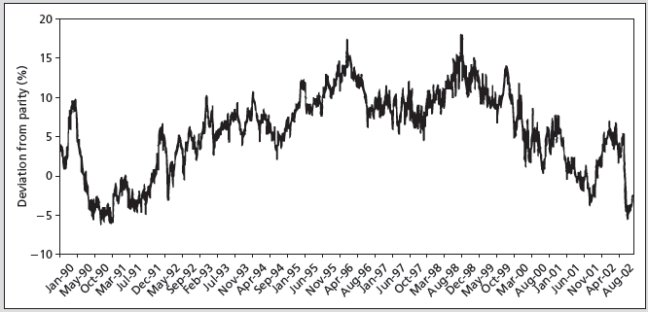
60:40 split of profits from merger between RD and Shell
Stock price ratio RD/Shell should = 60/40 = 1.5
If RD/Shell > 1.5, then short RD and buy Shell
If you had done this in 1993, you would have LOST money until 1999.

In 1907 Royal Dutch Petroleum merged with Shell Transport, although their stock continued to trade separately. Under the merger agreement RD receives 60% of the profits of the joint company and ST receives 40%. Hence the ratio of the share price of RD/ST should be 60/40 or 1.5. The price has deviated from this parity level for extended periods of time. There is similar evidence in equity carve outs and perhaps in closed-end fund discounts and premiums, although both of these may have other explanations. Remember Keynes’ quote, “Markets can remain irrational longer than you can remain solvent.” What if prices don’t conform to your models in the near term? This can be disastrous if you are levered. Ultimately this is why Long Term Capital Management Hedge Fund failed. In the long run, their bets were correct, but the markets did not return to ‘normal’ levels immediately and the fund’s excessive leverage caused it to fail.

Behavioralism provides stories designed to fit individual situations, but there is no coherent theory of behavior and some behaviors contradict others. Much of the empirical support for these ideas comes from the dot-com bubble and perhaps the housing bubble.

2. Technical Analysis and Behavioral Finance
PPT 9-15 through PPT 9-31
Technical analysis (TA) uses price and/or volume data to attempt to find undervalued securities. Technicians believe that there are predictable patterns in stock prices and that these patterns can be exploited to secure abnormal profits. Technical analysts believe that market prices conform to new data only slowly; giving rise to price trends, and that prices are affected by predictable behavioral or psychological factors. The so called ‘disposition effect’ may help explain the first TA belief. Under the disposition effect investors exhibit loss aversion so that they are reluctant to sell on bad news and price converges slowly to its new fundamental value. While some investors undoubtedly behave this way, this seems unlikely to be a true description of market prices behavior.

The PPT covers various simple technical analysis rules. There are a vast number of TA rules that can be used; some are far more complex than those described in the text. Technical rules include trends and correction techniques such as the Dow Theory and point and figure charts where chartists look for trends and congestion areas (the latter are periods where there is no apparent trend). Other indicators that technicians use are moving averages: when the stock price rises above the moving average, it is an indication that the stock will continue to increase in price and a buy signal is said to occur. A sell signal occurs when the stock price falls below the moving average. Some of the more popular charting methods used are defined.
Several sentiment indicators are displayed in the PPT.

The Trin statistic measures the number and trading volume on stocks that are advancing and declining
. 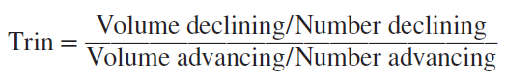
If the Trin statistic exceeds one, a bearish signal occurs. For many indicators, both bullish and bearish views are possible for the same relative measure of a statistic. Using the put/call ratio as an example, when the number of puts gets large relative to calls, a bearish interpretation may be inferred because investors buy puts to protect against stock price declines. If most investors are bearish, the number of puts will rise. Some contrarian investors argue that when the number of puts gets high it is an indicator that market participants are too pessimistic. For a contrarian, a rise in the put/call ratio is bullish.

As a final word of warning—the ability to discern apparent patterns with stock market prices means it is often possible to perceive patterns that may not exist. This is aptly illustrated in the
PPT using the associated figures in the text.

Actual Weekly Stock Price Changes, 52 Weeks

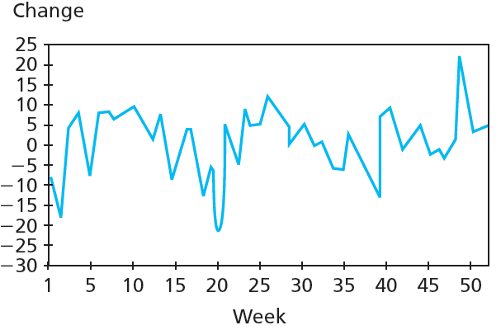

Simulated Weekly Stock Price Changes, 52 Weeks
