Chapter Ten
Bond Prices and yields

Chapter Outline

1. Bond Characteristics
PPT 10-2 through PPT 10-14
Basic characteristics of bonds follow in the PPT. Stress that the most common denomination is $1,000 for corporate bonds and Treasury bonds. Individual investors can buy $100 par T-notes and T-bonds but the standard is $1,000, and in many cases the bonds are bundled and sold as a group in multiples of $1,000. Bonds issued by federal agencies and municipalities may not have $1,000 par. Many will have substantially larger par amounts because of the institutional nature of these markets. Note the main differences with the municipal bonds are the tax features and insurance. Interest income on municipal bonds is not taxed at the federal level and often if an investor buys a bond issued by an entity in their home state the interest income is exempt from state taxes as well. Capital gains taxes will still apply. Many municipal bonds are insured by a bond insurer such as MBIA. This is done to improve marketability.

U.S. bonds are registered, but most bonds issued outside the U.S. are bearer bonds. With bearer bonds you must clip off the coupon and mail it in to get your interest as you are not a registered owner, although a broker can do this for you. With registered bonds the issuer and the issuer’s trustee know you are the owner and you will receive your interest and principal payments automatically. Registration helps the IRS ensure that interest income is declared for tax purposes.

A list of major corporate bond provisions is presented in the PPT. Secured bonds are backed by assets of the corporation which serve as collateral for the bond. Unsecured bonds, referred to as debentures, have no specific assets that serve as collateral. A callable bond gives the issuing corporation the right to call the bond back from the bond holders. The call provision is in the favor of the bond issuer, the issuer is likely to call in the bond when interest rates have fallen. The bond will be redeemed at a price over par, but the investor will reinvest in a lower interest-rate environment. The firm is not going to call the bond unless its market value is been above the call price. Most bonds are callable after an initial call protection period of 3 to 5 years. The quid pro quo is that bond issuers will have to pay a slightly higher yield rate if the bond is callable. Convertible bonds may be converted to common stock at the option of the bondholder. This favors the bondholder and the conversion ‘sweetener’ may reduce the required return. In a putable bond the bondholder has the right to put the bond back, sell it back, to the bond issuer, usually on a coupon payment date.

Foreign bonds are bonds issued by a borrower from a country other than the one in which the bond is sold. The bonds are denominated in the currency of the country in which it is sold. They are often given colorful names. For instance, Yankee bonds are bonds issued in the U.S. by foreign borrowers; they are denominated in U.S. dollars. Likewise, Samurai bonds are issued in Japan by non-Japanese borrowers and are denominated in yen. Bulldog bonds are issued in Great Britain by non-British borrowers and are denominated in British pounds. Eurodollar bonds are dollar-denominated bonds issued outside the U.S. They are thus not regulated under U.S. securities laws the way Yankee bonds are. Yankee bonds must be registered with the SEC, for example. Similarly Euroyen bonds are yen-denominated bonds that are issued outside of Japan. These offerings allow banks and corporate treasurers to borrow money in different currencies and at different interest rates.

A list of many of the key innovations in the bond market is provided. Developments in the asset-backed markets are changing traditional methods of finance for many corporations. One of the innovative types of bonds, inverse floaters, was a type of security held by Orange County Municipality when they went bankrupt. While they were holding the floaters, interest rates rose about 200 basis points, creating large losses on the bonds. The losses, coupled with a high degree of leverage caused the fund to go bankrupt.

2. Bond Pricing
PPT 10-15 through PPT 10-21
The bond pricing equation is presented in the PPT along with an example.

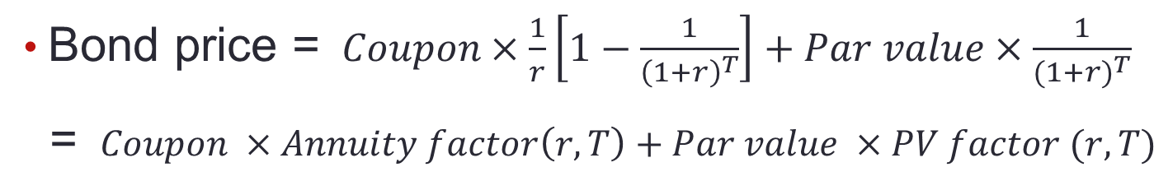
$\text{Accrued Interest}=\frac{\text{Annual Coupon\$}}{2}+\frac{\text{Days since last coupon payment}}{\text{Days between coupon payments}}$Prices that are quoted in the financial pages do not contain accrued interest. Most pricing examples that are used in finance also do not include accrued interest. Actual invoice prices to buy a bond will include any interest that has accrued since the last coupon payment. The flat price or quoted price assumes the bond is purchased on a coupon payment date. If the bond buyer purchases a bond between payment dates the buyer’s invoice price = flat price + accrued interest. Accrued interest can be calculated with the following formula:

The key provisions for a bond are outlined in the indenture (or contract) of the bond. Note that the indenture will specify a trustee to enforce the covenants in the bond contract. Covenants are specific provisions within the bond contract that specify things like payment terms, financial constraints on the bond issuers such as a maximum debt-to-equity ratio, minimum liquidity ratios, maximum dividend payment, etc.

3. Bond Yields
PPT 10-22 through PPT 10-27
The relationship between bond prices and yields along with a graph of the relationship is presented. The concept of yield to maturity can be related to prior work the students have done by equating it to the IRR. The yield to maturity is simply the discount rate that equates the present value of the cash flows from the bond to its current price. Finding the yield to maturity is a trial and error solution unless you have a financial calculator.

There is also a major assumption associated with this calculation. If the ytm solution is to be your actual rate of return one must reinvest each coupon as it is received for the remaining time to maturity at a reinvestment rate equal to the calculated promised yield. There is no mechanism to ensure that a bondholder can earn this rate of return. Mutual funds or a broker can automatically reinvest the coupon income but there is no guarantee it will earn the same promised yield rate. The ytm is the yield rate used to fix the price of the bond rather than the last word on what rate an investor can actually expect to earn. This is why the holding period yield (HPY) realized return should be calculated using the actual reinvestment rate on the coupon. You would then calculate the HPY using the modified internal rate of return methodology taught in corporate finance and presented in the text.

Alternative measures of yield are also presented. The current yield is measured by the annual dollar coupon divided by the current price of the bond. The discussion of current yield can also be tied to the discussion of discount and premium bonds through examples. The discount bond increases in price to compensate the bondholder for a lower current yield while the opposite occurs with a premium bond.
The PPT also displays how the call option affects value when comparing a callable and non-callable bond. The call provision caps the upside potential when rates decline. The impact that reinvesting has on future values is also shown.
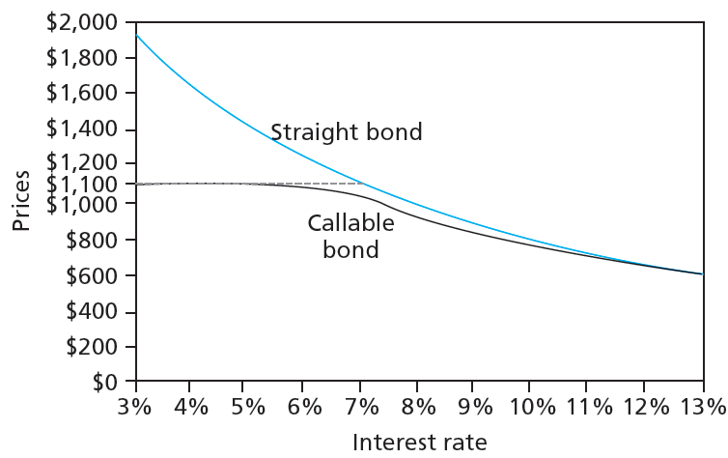

4. Bond Prices over Time
PPT 10-28 through PPT 10-32
The behavior of discount and premium bonds over time is presented. Class discussion of the reasoning behind the premium and discount, as it relates to current yields, helps students to understand pricing. A premium bond is priced above par because the coupon rate is too high relative to what the bond is supposed to be yielding. The only way to get the expected yield down to the ytm is to have the bond priced above par. In this case, the current yield on the bond will be above the promised yield. Hence there must be a capital loss on the premium bond over the year to get the overall yield down to the promised ytm. All bonds with a finite maturity experience these price movements over time. The PPT illustrate this:

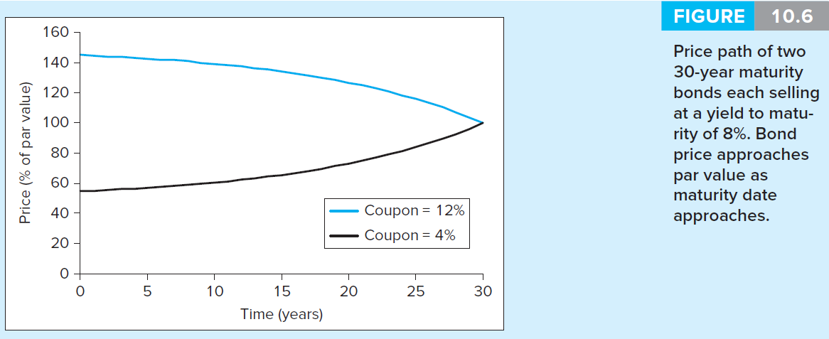
STRIPS are Treasury securities where the coupon payments and the final principal payment are ‘stripped’ out and sold separately. These can be useful for cash matching when a payment is due at a set time period in the future.

5. Default Risk and Bond Pricing
PPT 10-33 through PPT 10-44
The rating systems contain major and sub-categories that allow for differentiation in the major categories. The highest four major categories are labeled as investment grade. Bonds that have ratings in lower major categories are referred to as speculative grade or junk bonds. The major factors that determine a bond’s rating are provided The highest rated firms have high levels of profitability, high levels of cash flow to debt, high levels of coverage and liquidity ratios and lower levels of financial leverage.

Some bond contracts have covenants that provide protection against default. Sinking funds can prevent a cash crisis at maturity since they require the firm to systematically repay part of the principal. The larger cash flow requirements of a sinking fund can substantially reduce coverage and cash flow ratios prior to maturity and may not serve their intended purpose for all issues. Note that some sinking funds and serial bonds may actually hurt a bond investor’s rate of return. In some sinking funds the issuer may repurchase a given fraction of the outstanding bonds each year, but in others the issuer may either repurchase at the lower of the open market price or at a pre-specified price, usually par; in the latter case bonds are chosen randomly. The second type of sinking fund may hurt investors if interest rates fall; in the same way that calling bonds can hurt the bondholder. Serial bonds are not callable and this is a plus, but the staggered maturities can reduce the liquidity of the bonds and make them more expensive.

Subordination of future debt and dividend restrictions serve to protect existing creditors. Collateral provides the protection of asset value in case of default. Students should be aware that a bond without any collateral is termed a debenture.

Defaults, Credit Default Swaps (CDSs) and the Financial Crisis
During the credit crisis of 2008 the spread between Treasury bonds and junk-bond yields widened from 3% in 2007 to 15% at the start of 2009! Many blame the crisis on excessive use of exotic derivatives such as CDSs. They are partly correct, but the large number of factors led to the crisis. These include excess leverage, lax regulation, excessively cheap credit, congressional interference in the mortgage markets. Currency manipulation by export driven countries, unethical mortgage originators and misaligned executive pay incentives all played a significant role as well, along with major failures of the ratings agencies to identify the level of risk involved in mortgage securities.

Ratings agencies are paid by the firms issuing the securities. This creates a large conflict of interest between the issuer and the bond rater. The government has granted a monopoly to the top three rating agencies, although others exist. Even now, participation in TALF funding requires the securities be rated by one of the big three (Moody’s, S&P and Fitches). We have known for a long time that bond prices move ahead of announced downgrades in ratings. This is probably not due to information leakage ahead of the announced change, but rather due to the slowness of the agency to respond and the unwillingness to downgrade. Extrapolation bias also exists in the current agency-based paradigm as explained below.

A credit default swap (CDS) is an insurance policy on the default risk of a bond or loan. The seller of the swap collects an annual premium (and sometimes an upfront fee) from the swap buyer. The buyer of the swap collects nothing unless the bond issuer or loan borrower defaults, in which case the seller of the swap essentially pays the drop in value from par to the swap buyer. Hedge funds (and AIG!) are the main sellers of CDSs. They have sold the majority of investment grade and low-grade debt default swaps. CDSs can also be used to speculate on the financial health of firms as the swap buyer need not hold the underlying bond or loan.

At their peak there were reportedly $63 trillion worth of CDS; US GDP is about $15 trillion. Obviously if the economy experiences greater than expected defaults, these contracts magnify the losses many times over resulting in a series of defaults. More detail can help students to understand this problem. With a CDS there was no principal investment required; a low capital requirement (important if regulated); and with a strong seller credit rating, little collateral was required. The result was excessive risk taking on both sides. Buyers took on more risk because they were insured, even though insurer’s collateral was woefully inadequate. The Seller did not plan on having to ever make the payment so there was insufficient collateral or credit in place. This is also a good example of extrapolation bias discussed in the behavioral chapter. Financial modelers had modeled only a 5% percent chance of any drop in home prices on a national basis. Their models told them that writing the swaps was not risky. In hindsight, they were terribly wrong.

As the text points out, the lack of transparency in this market helped cause the credit freeze after the subprime mortgage crisis began. No one could tell the obligations and exposure of counterparties so it was too risky to make a loan. AIG had over $400 billion in CDS contracts on subprime mortgages and other loans and was going bankrupt. The failure of AIG might have trigged defaults at other institutions that were counting on payments from AIG to protect their own investments. Ultimately the government decided it was too risky to let AIG become insolvent. New regulations on CDSs will certainly be implemented although the industry is fighting the changes. CDS contracts will be required to be traded on an exchange with collateral requirements to limit risk. Exchange trading will also increase transparency of positions of institutions.
6. The Yield Curve
PPT 10-45 through PPT 10-51
The term structure of interest rates depicts the relationship between term to maturity and maturity for a group of bonds that are identical in all aspects except maturity. In practice, identical means the same rating, preferably the same coupon so that you don’t get into tax differences.

The expectations theory asserts that long-term rates are determined solely by expectations of future short-term rates. The liquidity preference theory asserts that long-term rates are determined by expectations of future short-term rates but also include added compensation, a liquidity premium, for greater risk.

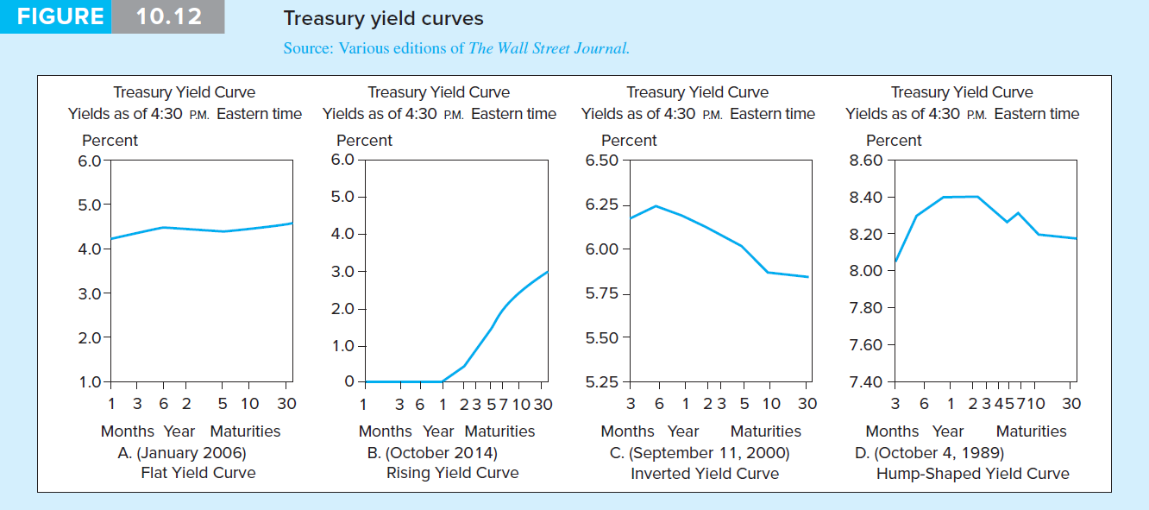

The instructor should consider talking about some of the broader events in the world in Figure 10.12 that may have influenced the yield curve.

The Pure Expectations Theory of the Term Structure
Long-term rates are a function of expected future short-term rates. This is the case with some restrictive assumptions. First, if transaction costs are zero, securities are perfectly divisible, and most importantly, future interest rates can be perfectly predicted. With these assumptions, a simple arbitrage argument will require that the long-term spot rate equal the (geometric) average of the expected future short-term rates. If the n-year long rate was above the average of the short-term rates, the investor could borrow money one year at a time and invest the money at the long rate for n years all at once. This yields a riskless profitable arbitrage that requires no initial investment. Investors are indifferent between investing for n years all at once, investing n years by investing a year at a time, or some combination thereof. This is a key point. In this case an upward-sloping term structure unambiguously implies that the market is expecting higher future short-term rates and a downward slope means that the market is expecting lower future short-term rates.

Liquidity Preference
The liquidity preference idea deals with the reality that future interest rates cannot be forecast perfectly so that the arbitrage argument used above is a risky arbitrage. More importantly it is riskier to invest for n years all at once as opposed to investing a year at a time for n years. Investors must be offered a premium to compensate them for the risk of a long-term investment. Hence, the long-term rate is greater than the (geometric) average of the expected future short-term rates. This implies that the actual term structure has an upward bias with respect to actual expectations of future rates because the observed long-term rate includes a risk premium.

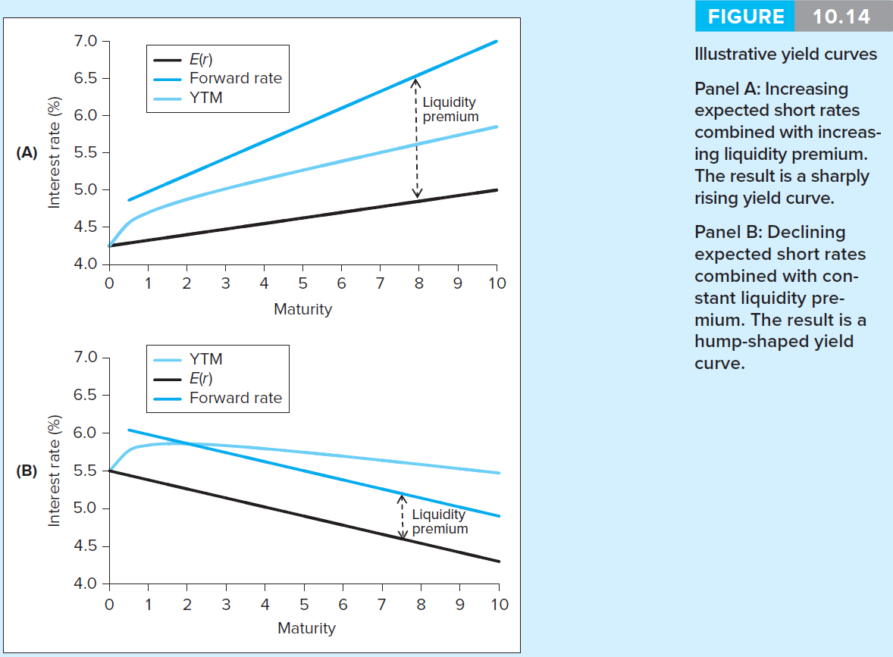

The formula for calculation of forward rates is presented. Depending on the scope of coverage in your class, it can be useful to extend the discussion to a multi-year context. Sample yield curves and volatility of term spreads are also provided.

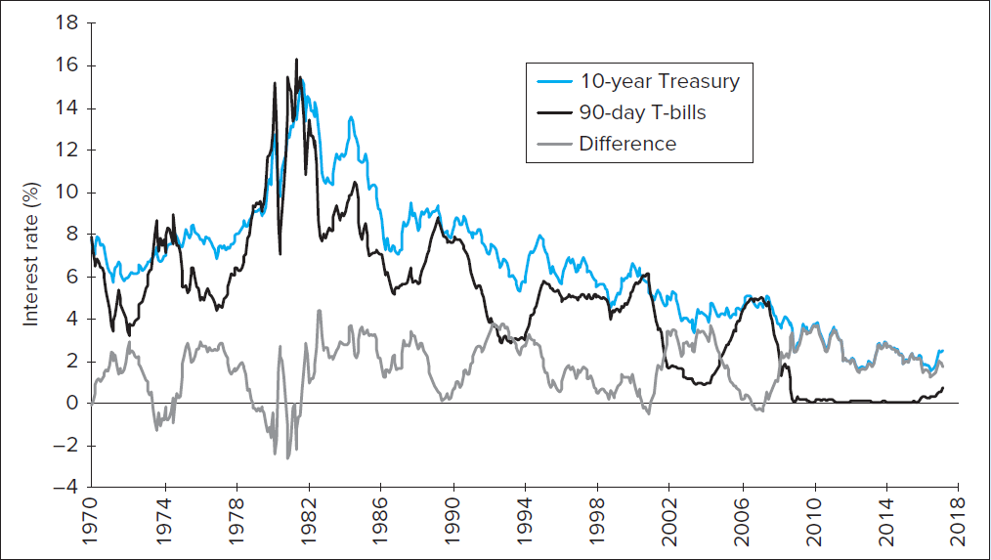

Excel Applications
Two excel spreadsheets for this chapter are available on the website. The first spreadsheet provides a template for students to calculate bond values and the second one calculates yield to maturity.

