Chapter Eleven
Managing bOND pORTFOLIOS

Chapter Outline
The basic decision involved in fixed-income management is the decision to purse an active- or a passive- investment strategy. An active strategy seeks to earn superior returns from the fixed-income portfolio. Superior returns can be earned if the investor can predict interest-rate movements that are not currently incorporated into a bond’s price or if the investor can identify bonds that are mispriced due to other factors. For example, finding a bond that has a credit-risk premium too large for its level of risk creates an opportunity to purchase a bond with an abnormally low price. Passive management of a bond portfolio focuses on earning the promised yield by minimizing the effects of interest-rate changes on the portfolio rate of return.

1. Interest Rate Risk
PPT 11-2 through PPT 11-13
As interest rates rise and fall, bondholders experience capital gains and losses and changes in the future value of reinvestment income. Thus bond yields are subject to interest-rate risk even when coupon and principal payments are paid as promised. The text and the PPT present six rules of bond pricing:
- Inverse relationship between bond price and interest rates (or yields)
- Long-term bonds are more price sensitive than short-term bonds. There are some exceptions to this rule because deep discount bonds can have a lower duration at longer maturities. This is pretty much a math quirk and won’t be true for most traded bonds.

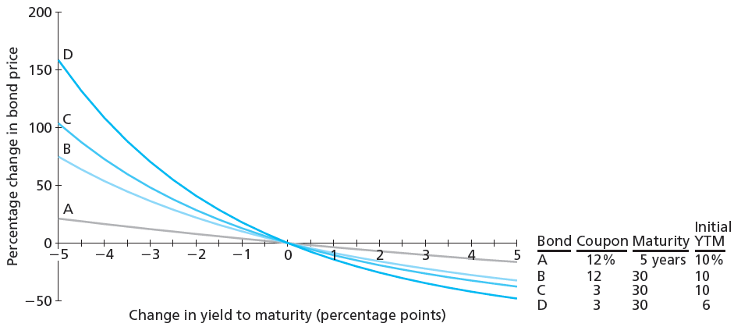

- Sensitivity of bond prices to changes in yields increases at a decreasing rate as maturity increases
- A bond’s price sensitivity is inversely related to the bond’s coupon. If interest rates increase and the investor has a high-coupon bond, he is getting more current income to reinvest at the new higher rates. Therefor his bond price is not affected as much as a bond with a lower coupon and vice versa.
- Sensitivity of a bond’s price to a change in its yield is inversely related to the yield to maturity at which the bond currently is selling. At higher yield rates the present values of the more distant cash flows are reduced by more than the present value of the nearer-in-time cash flows. Thus at higher yield rates the near-term cash flows make up a higher percentage of the bond’s value. With more of the value based on near-term cash flows, the bond will have lower price volatility.
- An increase in a bond’s yield to maturity results in a smaller price decline than the gain associated with a decrease in yield. This is an characteristic of convexity. Because the bond-price-interest-rate relationship is curvilinear, a given increase in interest rates results in a different percentage price change than the same decrease in rates.

The main points can be succinctly summarized:
- Any security that gives an investor more money back sooner (as a % of investment) will have lower price volatility when interest rates change.
- Maturity is a major determinant of bond-price sensitivity to interest-rate changes, but;
- It is not the only factor; in particular the coupon rate and the current ytm are also major determinants.

Be careful not to equate lower price volatility with lower interest-rate risk. Interest-rate risk is reduced by minimizing the difference between the duration of the bond portfolio and the investor’s investment horizon and not necessarily by reducing the duration or the price volatility.

Duration is the first derivative of the bond-price formula with respect to interest rates. The description of duration used here stresses the concept of average life. Since the measurement of duration considers the timing and value of intermediate payments, it is an accurate measure of average life and is more meaningful than maturity for a bond that has coupon payments.

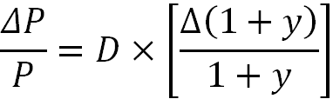

Students have a difficult time grasping the concept of duration even when given the definition. The weight of each cash flow for a fixed-income instrument is the present value of the cash flow as a percentage of total value. Duration is the sum of the product of the weights of each cash flow and the period that it is received. The measure is in units of the cash-flow payment during the year. For example, with a mortgage that has monthly payments, duration would be in months. For a bond with semi-annual compounding, the measure would be in 6-month periods. The duration is affected by the coupon rate, the discount rate and maturity.

Duration can be used to predict the price change of a coupon bond when interest rates change because price changes on fixed-income securities are approximately proportional to duration. Duration incorporates both the coupon rate and maturity effects on price volatility into a single measure. The concept of modified duration is used extensively in the industry.

The text also presents modified duration but it does not really explain why modified duration is useful.
D* = modified duration
  - 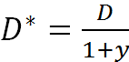
  - 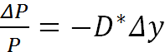
The minus sign in this equation reminds us that if interest rates go up, prices go down and vice versa. Although the text simplifies this you have to be careful using modified duration. It is used for instruments that have non-annual cash flows as follows:
“Modified duration” = Duration_{Mod}
The purpose is for use with bonds and loans with non-annual payments
Duration_{Mod} = Duration_{Annual} / (1 + r_{period}); where r_{period} = periodic interest rate, typically semiannual for a bond
The predicted price change using modified duration is
ΔP/P = -Duration_{Mod} * Δr_{Annual}

Notice that using modified duration allows one to plug in the annual rate change rather than the change in semi-annual rates. This is why it is commonly used by practitioners.

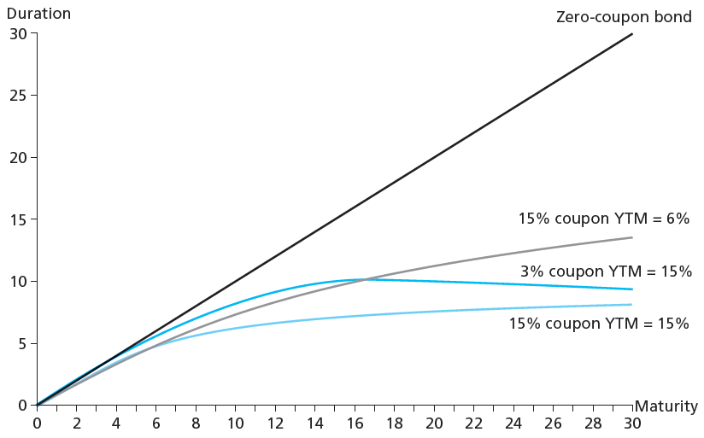

2. Passive Bond Management
PPT 11-14 through PPT 11-19
Interest-rate risk is the possibility that an investor does not earn the promised ytm because of interest rate changes. A bond investor faces two types of interest-rate risk:
- Price risk: The risk that an investor cannot sell the bond for as much as anticipated. An increase in interest rates reduces the sale price.
- Reinvestment risk: The risk that the investor will not be able to reinvest the coupons at the promised yield rate. A decrease in interest rates reduces the future value of the reinvested coupons.

The two types of risk are potentially offsetting because if interest rates rise, the sale price will fall but the reinvestment income will be higher and vice versa. If one could choose just the right amount of price volatility to offset the change in the future value of the reinvestment income one could eliminate interest-rate risk. This is the concept of ‘immunization.’

Immunization of interest-rate risk is a tool that can be used for a type of passive management. Immunization is an investment strategy designed to ensure the investor earns the promised ytm. Financial institutions use immunization to minimize risk to their rate of return on investments. Immunization is also used to minimize the exposure of their equity to interest-rate changes on their financial assets and liabilities.

To control for interest-rate risk, managers of financial institutions minimize the difference between the durations of their asset and liability portfolios. Target-date immunization can be used to lock in a fixed rate of return for some investment horizon. If the duration of the fixed-income investments equals the desired holding period, reinvestment risk and price offset one another and it is possible to approximately lock in a rate of return. Numerical and graphical illustrations of the concept of immunization are presented.

Cash-flow matching is another passive form of immunization but is more costly to implement as cash flows must match a series of obligations. Dedication is simply multi-period cash-flow matching. Note that this can be done with a set of zeros of different maturities or with coupon bonds. The STRIPS mentioned in the prior chapter can be useful for this purpose.

There are some problems with immunization strategies:
- May be suboptimal if you have a rate forecast and are willing to take a position on which way rates will move. If you think rates will fall you want a duration longer than your investment horizon. If you are right, the portfolio will earn more than the promised ytm. If you think rates will increase, you want a duration shorter than your investment horizon. Again, if you are right, the portfolio will earn more than the promised ytm. Note that this goes against conventional wisdom which states that you are hurt in bonds by rising interest rates. (Real returns may be reduced if the rate increase is due to inflation, but not nominal returns.)
- Does not work as well for complex portfolios with option components, nor for large interest rate changes
- Because duration and the time-to-investment horizon change at different rates, immunization requires periodic rebalancing, which incurs transaction costs

3. Convexity
PPT 11-20 through PPT 11-21
Because duration is the first derivative of the bond-price formula, its price change predictions strictly hold only for infinitesimally small interest-rate changes. For larger interest-rate changes, duration predictions will be wrong. The duration prediction is always pessimistic. It predicts a larger price drop than will occur if interest rates rise and predicts a smaller price increase than will actually occur if interest rates fall. Convexity corrects for these errors. Convexity measures the degree of curvature in the bond-price-interest-rate relationship. Price change predictions that include convexity are quite accurate.

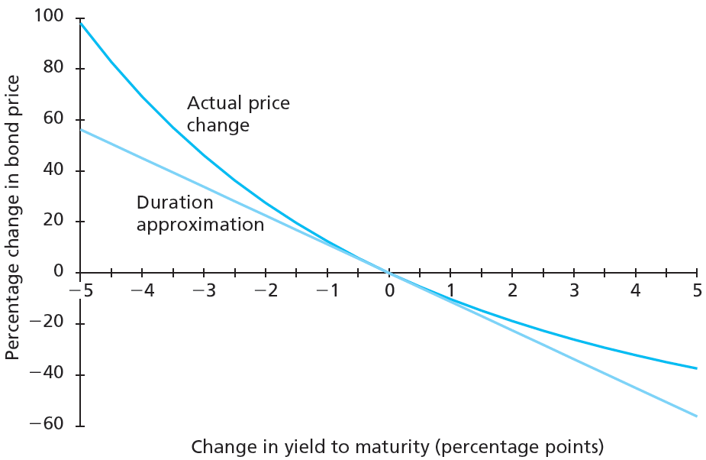

The convexity formula and the predicted ΔP/P formula with convexity are:

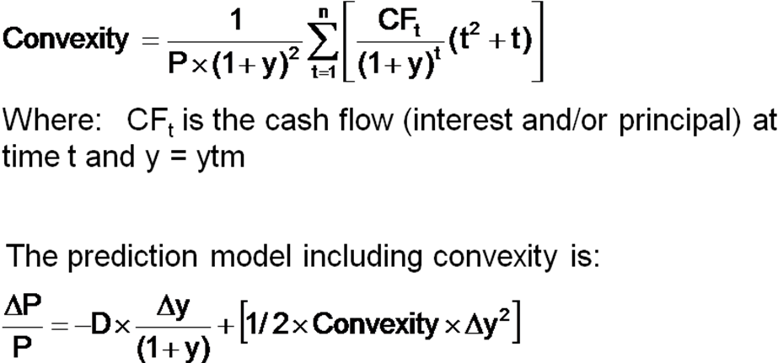

4. Active Bond Management
PPT 11-22 through PPT 11-23
Several active bond strategies are presented. Various bond swaps may be instituted when the fixed-income portfolio is being actively managed. Substitution, intermarket spread and rate anticipation swaps require some level of market disequilibrium. With a substitution swap, two bonds that are substitutes offer different rates of return. The strategy involves purchase of the bond with the higher rate of return and selling the bond that has the lower rate of return.

The intermarket swap requires some disequilibrium in the markets as well. In an intermarket swap, the bonds could be of different credit risk but the interest-rate differential is not perceived as correct. The rate-anticipation swap involves changing the duration of the fixed-income portfolio to profit from a change in interest rates. The change in interest rates must not be anticipated by the rest of the market for the swap to result in superior profits.

The remaining two swaps do not require market disequilibrium to be profitable. A pure-yield pick-up involves a risk/return trade-off decision by an investor. A tax swap involves a purchase and sale of fixed-income securities to take advantage of an individual investor’s tax position.
Horizon analysis is a form of interest-rate forecasting where an analyst selects a particular investment period and predicts bond yields at the end of that period.

