Chapter Fourteen
Financial Statement Analysis

CHAPTER OUTLINE
1. The Major Financial Statements
PPT 14-2 through PPT 14-5
Financial statement analysis uses the firm’s accounting data. The financial statements are the starting point of a financial analysis. The income statement contains flows that occur during the current period that relate to profitability primarily. The balance sheet gives an analyst a snapshot for the firm’s financial position and a broad overview of the level of investments in major asset categories. Analysts typically work with common size statements to remove size distortions. Indexed or trend statements are used to analyze changes over time.

Accounting earnings are earnings reported on the income statement that follow a set of generally accepted, but widely divergent, accounting practices. Economic earnings are the sustainable cash flow to the stockholders that does not impair the productive capacity of the firm.

The statement of cash flows removes much of the effects of accrual accounting to give the analyst a better look at the cash flows of the firm. The statement of cash flows recognizes only transactions in which cash changes hands. Analyzing cash flows and estimating their future levels is the crux of financial forecasting. It may be worthwhile to go beyond the text and discuss cash flow modeling of the firm according to the statement of cash flows:
Cash Flow = Operating Cash Flow + Cash Flows from Investing + Cash Flow from Financing
Operating Cash Flow = Net income + Depreciation + Net Operating Sources of Funds
Net Operating Sources of Funds
= Working capital operating sources of funds – working capital operating uses of funds

Cash Flow from Investing would include net investments in fixed assets and Cash Flow from Financing will contain changes in debt and equity accounts and dividends. Note that interest expense is not included in Cash Flow from Financing and is also not added back to Operating Cash Flow.

Not all sources of funds are equal in terms of their sustainability. A firm can increase its cash by becoming more profitable (generally a good thing), by divesting fixed assets (which could be good or bad depending on the earnings potential of the assets) or by increasing financing sources (which is probably not sustainable).

Financial statement analysis can often lead the analyst to general conclusions about a firm, but it rarely gives the analyst a sufficiently complete picture to make a forecast.

2. Measuring Firm Performance
PPT 14-6 through PPT 14-7
Two broad activities are the responsibility of a firm’s financial managers: investment decisions and financing decisions. Investment, or capital budgeting, decisions pertain to the firm’s use of capital, while financial decisions pertain to the firm’s sources of capital. Aspects of both efficiency and profitability can be measured with a several ratios: efficiency is typically assessed using several turnover ratios, while the profitability of sales is commonly measured with various profit margins. When evaluating financing decisions, look at both leverage and liquidity. Aspects of each of these two concepts can be measured with an array of statistics.

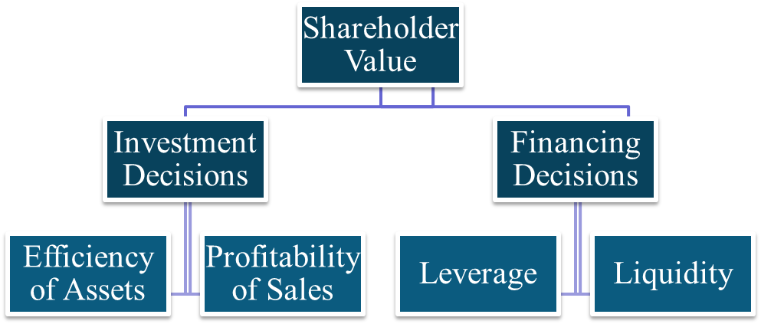

3. Profitability Measures
PPT 14-8 through PPT 14-12
Return on equity and return on assets are total earnings expressed on a per-dollar invested basis. The firm’s financial policies affect how ROA and ROE are linked because ROE is after tax and ROA is before interest and taxes. Note that the text uses ROA = EBIT / Assets, whereas many other texts calculate ROA = NI / Assets. It is crucial that the instructor make this point with the students. In concept the text uses a measure of operating return on assets rather than an overall return on assets.

The relationship between ROA and ROE is presented:

This relationship can be used to illustrate a key point about leverage and the return on equity. Using debt in the capital structure can increase the ROE if the ROA is greater than the interest rate on the debt. Hence, the choice of the optimal capital structure will be dependent on expected earnings on investments in relation to the cost of debt. Few students will understand this, but they should for their investment choices and in their personal finances. Because the interest expense is a fixed cost it adds to the risk of the firm. There is no free lunch, seeking higher returns requires taking on more risk.

The concept of economic value added is another tool that can be used to analyze a company’s performance. Economic value added compares return on assets with a cost to the capital that is required to make the investment in assets. The main point of the analysis is that management adds value to stockholders by retaining earnings and reinvesting only if the ROE > k. The related point should also be made, namely that EPS growth can be generated simply by retaining earnings, but this does not mean the firm is adding value or maximizing shareholder wealth unless the return on the investment is greater than k.

4. Ratio Analysis
PPT 14-13 through PPT 14-26
Ratio analysis is used to highlight specific aspects of performance. All ratios require a benchmark (although ‘rules of thumb’ have been developed for some) for comparison. The benchmark may be the same ratio in a different time period or the value of a competitor or group of competitors. Ratios are very important to the investment community and are used extensively in security analysis. They are also used by credit rating agencies to establish security ratings.

ROE = Net Income/Equity is the key bottom line ratio in financial statement analysis because it is a measure of the accounting return to equity. Literally it measures the firm’s ability to convert a dollar of equity invested in the firm into bottom line profitability. ROE can be decomposed as follows:
$\begin{aligned}\text{ROE}=\frac{\text{Net Profit}}{\text{Pretax Profit}}×\frac{\text{Pretax Profit}}{\text{EBIT}}×\frac{\text{EBIT}}{\text{Sales}}×\frac{\text{Sales}}{\text{Assets}}×\frac{\text{Assets}}{\text{Equity}} \\ (1) × (2) × (3) × (4) × (5) \\ \text{ Tax }×\text{ Interest }×\text{ Margin }×\text{ Turnover}×\text{ Leverage} \\ \text{ Burden Burden}\end{aligned}$

Ratio (1) Tax Burden (TB) measures the percentage of pretax profit that the firm keeps after paying taxes. Ratio (2) Interest Burden (IB) measures the percent of EBIT kept after paying interest expense. This ratio is 1 if the firm has no debt. One can see this by restating the relationship as follows:
$\frac{\text{Pretax Profit}}{\text{EBIT}}=\frac{\text{EBIT}−\text{Interest Expense}}{\text{EBIT}}$

The IB ratio is closely related to the times interest earned or TIE = EBIT / Interest expense. A high TIE indicates a low probability of bankruptcy. 1 – (1/TIE) = maximum sustainable drop in EBIT that just allows the firm to cover its interest expense. With a TIE of 5 for instance, the firm could lose 1 – (1/5) = 80% of its EBIT and still just cover its interest expense.

Ratio (3) Operating Profit Margin measures the percentage of sales revenue that remains after subtracting cost of goods sold, selling and administrative expenses and depreciation. Ratio (4) Asset Turnover Ratio (ATO) measures the efficiency of the firm at generating sales per dollar invested in the assets. The Margin x ATO = ROA.

Ratio (5) Leverage ratio = 1 + Debt / Equity. The leverage ratio is a measure of the percentage of debt in total capitalization. Note that it appears that using more debt as a percent of capital will increase ROE, but using more debt also reduces the interest burden ratio.

The various debt ratios are all algebraically equivalent. Knowing the Debt / Asset ratio, one can find the Equity / Asset ratio because the two ratios must sum to 1. Taking the ratio of these two will give one the Debt / Equity ratio and adding 1 to that will give the leverage ratio.

The decomposition process allows an analyst to see what factors have the most significant influence on the summary measure. For example, analysis and comparison of the factors 3, 4 and 5 highlight profit margin on sales, total asset turnover and leverage (equity multiplier). When factors 3 and 4 are multiplied together, the analyst has a measure of EBIT/Assets. This measures the operational profit of the firm without the financial leverage. The decomposition is useful in highlighting relevant factors influencing overall profit.

The types of ratios and the individual ratios that are used for the different types of ratios vary in importance for different industries. For example, inventory turnover is not critical for a service firm while inventory turnover is critical for a manufacturer.

Profitability ratios measure profits to sales, assets or equity. All profitability measures that include net income are subject to potential problems in comparability. Since net income is influenced by financial leverage, if firms use different amounts of borrowing, it is difficult to compare the profitability directly. We would expect firms with more leverage to have higher levels of profitability but firms using higher degrees of leverage are also riskier than firms that do not use as much debt.

Management efficiency or activity ratios are used to assess the effectiveness of management in generating sales. The most common types of management efficiency ratios are turnover measures that tie sales to assets or groups of assets. Generally, higher levels of turnover mean that the company is using its assets more efficiently in generation of sales.

Liquidity ratios are designed to measure the firm’s ability to meet a short term obligation. The current ratio and the quick ratio are commonly used to measure liquidity.

Leverage ratios are used to investigate the firm’s use of debt. Times-interest-earned and fixed-charge-coverage ratios are used to assess the firm’s ability to service debt. Debt to assets and debt to equity are used to assess how much debt financing the firm is using.

The price-to-earnings and market-to-book ratios are presented. These ratios are regularly reported and discussed in the financial press. The relevance of the market to book ratio varies with industries. The relevance depends on how accurately the book value reflects economic value and how significant asset levels are in the production of profits and sales. Analysts also use the price-to-sales ratio as an indicator of how a stock is valued, particularly if a firm has low or negative earnings.

5. An Illustration of Financial Statement Analysis
PPT 14-27 through PPT 14-29
Some of the issues that short-term borrowing brings to analysis are illustrated by the example using Growth Industries, Inc. Key ratios and the statement of cash flows for Growth Industries, Inc. show that careful analysis of financial ratios can indicate problems that may not be presented in the annual report. The analysis shows that ROE is declining while ROA is remaining steady. The firm is using large amounts of long-term debt to maintain its 20% growth in assets and this is not sustainable for very long.

6. Comparability Problems
PPT 14-30 through PPT 14-36
Since financial ratios are based on accounting data, an analyst must be aware of differences in accounting methods that could affect comparison of ratios. Some of the key problems of comparability include different inventory valuation methods. This is an important factor since it influences cost of goods sold, which is the major component of costs on most income statements. There are also various problems related to depreciation. First, accounting depreciation is different from economic depreciation. Firms can also choose different methods of depreciation. Depreciation affects reported income and reported asset values. Inflation can distort reported income and the balance sheet. Differences in international accounting standards make comparisons of international firms difficult. With the increased pressure on firms to meet expected earnings, more management of earnings is taking place in today’s environment. Fair value accounting uses market values rather than book values in the firm’s financial statements. Market value is a truer picture of the current value of the firm, as market value is forward looking and book value is backward looking. The trend is toward market value accounting Financial Accounting Standards Board (FASB) Rule 157 classifies assets in one of three categories: Level 1: Assets that are traded in active markets and should be valued at market prices, Level 2: Asset that are not actively traded, but their values may be estimated from market data on similar assets, Level 3: Assets that can only be valued with inputs that are difficult to observe. Level 2 and Level 3 assets may be valued using pricing models and the values may be ‘marked to model.’

Note that banks must mark to market some of their asset holdings. Bankers have fought mark to market rules for years, sometimes claiming it couldn’t be done, and other times claiming it shouldn’t be done. The financial crisis has exacerbated the debate. We learned from the S&L crisis of the 1980s and from Japan in the 1990s that you should have mark to market rules. Otherwise the financial statements are hiding losses in periods of distress. It may make sense to mark to a calculated fundamental value rather than market value if market value is at fire sale prices during periods when markets are not functioning properly.

A list of items used by analysts to assess the quality of earnings is displayed in the PPT. A firm in the modern corporate environment has a great deal of flexibility in reporting and quality is a real issue.

International accounting conventions are presented in the final part of this section. Quality of earnings refers to the realism and sustainability of reported earnings. This implies that
- Allowance for bad debts must be realistic
- Extraordinary and Non-recurring items are sometimes pretty ordinary and common
- Earnings smoothing is pervasive
- Revenue & expense recognition options
- Engaging in contingent off-balance sheet assets (certain leases) or liabilities (selling credit default swaps) that have unknowable effects on earnings
Remember that earnings are supposed to translate into cash flow and we are always trying to identify the trend in expected future cash flows.

International Accounting Conventions
Overseas firms have far more discretion in their ability to set aside reserves for future contingencies (or not) than U.S. firms have. This means foreign firms’ earnings are more subject to managerial manipulation. Foreign firms typically use accelerated depreciation on their financial statements and U.S. firms do not, so foreign firms have lower reported earnings, ceteris paribus. Treatment of intangibles varies widely between countries as well, increasing comparability problems. The International Financial Reporting Standards (IFRS) have been adopted by the European Union and by over 100 countries.

In 2007 the SEC began allowing foreign firms to list their securities in U.S. markets if they prepared their statements using IFRS. In 2008 the SEC ruled that large U.S. multinational firms may start using IFRS rather than GAAP in 2010 and that all firms should use IFRS by 2014. IFRS standards are principle based rather than rules based. The IFRS standards will generally allow more flexibility in reporting standards.

Operating sources and uses should include changes in working capital accounts related to operations such as inventories and receivables and should exclude non-operating sources and uses such as bank loans and short term notes payables.

